## INDEX

|  |  |  |
| --- | --- | --- |
| **Sl. No.** | **Topic** | **Page No.** |
| 1 | Introduction | 2-3 |
| 2 | Description | 4-6 |
| 3 | Goal & Objective | 7-8 |
| 4 | System Specification | 9-10 |
| 5 | Technology | 11-16 |
| 6 | Requirement Analysis | 17-21 |
| 7 | Designing | 22-23 |
| 8 | Coding | 24-79 |
| 9 | Testing | 80-82 |
| 10 | Front Page Display | 83-96 |
| 11 | Future Scope | 97-99 |
| 12 | Conclusion | 100-102 |
| 13 | References | 103-104 |

**INTRODUCTION**

###### INTRODUCTION

“Online Medicine Store” Site is a tool which is used in the automation of Medicine Selection and Purchase in an Online. In this tool, the medicine will be automated, Searched and Purchased by the customers dynamically and the reports on the same.

The proposed system of Online Medicine Store Site is fully an automated one. In the proposed Shopping Site, the customer in online can view the Medicine and requirements put forward by them. Online Medicine purchase is also possible with this system. As the proposed system is a centralized one, redundancy can be avoided; moreover the coordination of different departments becomes much easier.

The online interaction between Customers and administrator is also possible. The administrator is the one who is adding all the medicine details either through online or in direct for editing medicine day by day manner. The present era is technically far advanced. With the rapid growth in technology, the life style of a human being is changing on a very high pace. This advanced technology provides an average human being with opportunity of leading a comfortable life.

The E medicine system enables vendors to set up online shops for medicine, and also helps customers to buy medicine online , and a system administrator to approve and reject requests for new medicial store and maintain lists of store categories.Also on the agenda is designing an E-medicial site to manage the items in the shop and also help customers purchase them online without having to visit the medicine store physically.Our online E medical store will use the internet as the sole method for selling medicine to its consumers. Buying will be highly personalized and the items will provides at lower prices than most competitors.

# DESCRIPTION

###### Existing System

The Existing system for Online Medicine Store System is a manual process. Taking existing system in to consideration, we can find that the customer has to interact with the Medicine Shops in person, brief on the requirements they expect and so on. All these require more time and labor. The data collected may be inconsistent, redundant and getting in touch with a remote customer will become impossible.

###### Drawbacks of the Existing System:

The existing system has the following disadvantages:

1. Requires many departments to handle variety of tasks.
2. Involves lot of paper work.
3. No proper assignment of responsibilities would be there.
4. No electronic workflow, processing and approvals.
5. No automation and centralization of records.
6. Low and dragging access to records and details on employees.
7. New changes cannot be easily implemented.
8. Loss of records is probable to occur, as it is paper works.
9. Difficulty in searching the records as no serialization is involved.

Accumulation of records as organization extends

###### Proposed System:

The proposed system Online Medicine Store is fully an automated one. In the proposed system, the customer online can view the medicine details and requirements put forward by them. Online registration is also possible with this the proposed system. As the proposed system is a centralized one, redundancy can be avoided; moreover the coordination of different departments becomes much easier.

Above all the system provides high security for all its data. The proposed system is mainly required for the listed as:

1. Easy updating of information
2. Provides online registration facility
3. Status of processing can be verified and identified at any stage of process

###### Need for Proposed System:

1. Improve business practices and streamline operations.
2. Reduce the need for departmental system.
3. Provide a single point of entry for information.
4. Provide electronic workflow, processing’s and approvals.
5. Automate audits and edits, and centralize rules administration.
6. Improve information access at the employee, user and administrative levels.
7. Provides new functionality.
8. Entry-level users have been provided with the facility to access and complete online forms.
9. Automatic review of plans, policies and eligibility requirements.
10. Automatic identification of taxable wages.
11. The time keeping function included in the proposed system will supports the capture of information based on an employee’s work schedule.
12. The Leave Management module maintains balances for leave benefits and balances.
13. Non-technical users will be able to create and retrieve contrivance planning management reports.
14. Electronic routing and approvals of attendance can be implemented.
15. Access and ability to change personal information such as contact address,email address etc.

**GOAL & OBJECTIVE**

###### OBJECTIVE

This is a project for Online Medicine Store or E-medicine. The basic idea is that customer’s can buy medicine online. It consists of item details, status and delivery. The administrator can enter the name and password and generate the report and can perform operations like add, search, delete the products in the database.

E-medicine is a unique health portal for medicine and health care product.it is an attempt to make live easier by providing

Multiple options medicines from the comfort of our homes and offices too.

Through this portal we can online buy medicines,child care,nutritional suppliments,health monitors,orthopadetic products,elder care and beauty and personal care.

The present era is technically far advanced. With the rapid growth in technology, the life style of a human being is changing on a very high pace. This advanced technology provides an average human being with opportunity of leading a comfortable life.

The E medicine system enables vendors to set up online shops for medicine, and also helps customers to buy medicine online , and a system administrator to approve and reject requests for new medicial store and maintain lists of store categories.Also on the agenda is designing an E-medicial site to manage the items in the shop and also help customers purchase them online without having to visit the medicine store physically.Our online E medical store will use the internet as the sole method for selling medicine to its consumers. Buying will be highly personalized and the items will provides at lower prices than most competitors.

**SYSTEM SPECIFICATION**

###### Hardware Configurations:

Processor : Pentium 4, higher version

RAM : 512 MB

Hard Disk : 40 GB space

###### Software Configurations:

Operating System : windows 2000, xp ,vista , windows7 Web Server : Xamp

Technology : PHP

Backend : mysql Scripting language : php

Web Design : HTML, HTML5, CSS

# TECHNOLOGY

###### About the technology

PHP is a server-side scripting language designed for web development but also used as a general-purpose programming language. PHP is now installed on more than 244 million websites and 2.1 million web servers. Originally created by Rasmus Lerdorf in 1995, the reference implementation of PHP is now produced by The PHP Group. While PHP originally stood for *Personal Home Page*, it now stands for *PHP: Hypertext Preprocessor*, a recursive acronym.

PHP code is interpreted by a web server with a PHP processor module, which generates the resulting web page: PHP commands can be embedded directly into an HTML source document rather than calling an external file to process data. It has also evolved to include a command-line interfacecapability and can be used in standalone graphical applications.

PHP is free software released under the PHP License, which is incompatible with the GNU General Public License (GPL) due to restrictions on the usage of the term *PHP*. PHP can be deployed on most web servers and also as a standalone shell on almost every operating system and platform, free of charge PHP development began in 1994 when the developer Rasmus Lerdorf wrote a series of [Common Gateway](http://en.wikipedia.org/wiki/Common_Gateway_Interface) [Interface](http://en.wikipedia.org/wiki/Common_Gateway_Interface) (CGI) [Perl](http://en.wikipedia.org/wiki/Perl) scripts, which he used to maintain his [personal homepage.](http://en.wikipedia.org/wiki/Personal_homepage) The tools performed tasks such as displaying his résumé and recording his [web traffic.](http://en.wikipedia.org/wiki/Web_traffic)

**FRONT END USED**

###### Hyper Text Markup Language (HTML):-

HTML, or Hyper Text Markup Language, has two essential features hypertext and universality. Hypertext means you can create a link in a Web page that leads the visitor to any other Web page or to practically anything else on the Internet. It means that the information on the Web can be accessed from many different directions. Tim Berners- Lee, the creator of the Web, wanted it to work more like a person's brain and less like a static source of data, such as a book.

Universality means that because HTML documents are saved as Text Only files, virtually any computer can read a Web page. It doesn't matter if your visitors have Macintosh or Windows machines, or whether they're on a Unix box or even a handheld device like a Palm. The Web is open to all.

###### Hyper Text Markup Language (HTML 5):-

Html5 was developed to solve compatibility problem that effect the current standard HTML-4 one of the biggest differences between html5 and previous version is that older version require properitary plugins and API’s (This is why a web page that was built and tested in one browser may not load correctly in another browser).HTML5 provides one comman interface to make loading elements easier.

One of the design goals for HTML5 to support multimedia on mobile devices . New syntactic features were introduced to support such as video ,audio, and canvas tags.

###### Cascading Style Sheet (CSS):-

Cascading Style Sheets (CSS) are a powerful way to affect the presentation of a document or a collection of documents. Obviously, CSS is basically useless without a document of some sort, since it would have no content to present. Of course, the definition of "document" is extremely broad. For example, Mozilla and related browsers

use CSS to affect the presentation of the browser chrome itself. Still, without the content of the chrome buttons, address inputs, dialog boxes, windows, and so on there would be no need for CSS (or any other presentational information).

It is possible to completely change the way elements are presented by a user agent. This can be executed at a basic level with the display property, and in a different way by associating style sheets with a document. The user will never know whether this is done via an external or embedded style sheet, or even with an inline style. The real importance of external style sheets is the way in which they allow authors to put all of a site's presentation information in one place, and point all of the documents to that place. This not only makes site updates and maintenance a breeze, but it helps to save bandwidth since all of the presentation is removed from documents.

To make the most of the power of CSS, authors need to know how to associate a set of styles with the elements in a document. To fully understand how CSS can do all of this, authors need a firm grasp of the way CSS selects pieces of a document for styling, which is the subject of the next chapter.

#### BACK END USED

###### MYSQL

MySQL, the most popular Open Source SQL database management system, is developed, distributed, and supported by Oracle Corporation.

###### MySQL is a database management system.

A database is a structured collection of data. It may be anything from a simple shopping list to a picture gallery or the vast amounts of information in a corporate network. To add, access, and process data stored in a computer database, you need a database management system such as MySQL Server. Since computers are very good at handling large amounts of data, database management systems play

a central role in computing, as standalone utilities, or as parts of other applications.

###### My SQL databases are relational.

A relational database stores data in separate tables rather than putting all the data in one big storeroom. The database structures are organized into physical files optimized for speed. The logical model, with objects such as databases, tables, views, rows, and columns, offers a flexible programming environment. You set up rules governing the relationships between different data fields, such as one-to- one, one-to-many, unique, required or optional, and “pointers” between different tables. The database enforces these rules, so that with a well-designed database, your application never sees inconsistent, duplicate, orphan, out-of-date, or missing data.

The SQL part of “My SQL” stands for “Structured Query Language”. SQL is the most common standardized language used to access databases. Depending on your programming environment, you might enter SQL directly (for example, to generate reports), embed SQL statements into code written in another language, or use a language-specific API that hides the SQL syntax.

SQL is defined by the ANSI/ISO SQL Standard. The SQL standard has been evolving since 1986 and several versions exist. In this manual, “SQL-92” refers to the standard released in 1992, “SQL:1999” refers to the standard released in 1999, and “SQL:2003” refers to the current version of the standard. We use the phrase “the SQL standard” to mean the current version of the SQL Standard at any time.

###### My SQL software is Open Source.

Open Source means that it is possible for anyone to use and modify the software. Anybody can download the My SQL software from the Internet and use it without paying anything. If you wish, you may study the source code and change it to suit your needs.

###### The MySQL Database Server is very fast, reliable, scalable, and easy to use.

If that is what you are looking for, you should give it a try. My SQL Server can run comfortably on a desktop or laptop, alongside your other applications, web servers, and so on, requiring little or no attention. If you dedicate an entire machine to My SQL, you can adjust the settings to take advantage of all the memory, CPU power, and I/O capacity available. MySQL can also scale up to clusters of machines, networked together. My SQL Server was originally developed to handle large databases much faster than existing solutions and has been successfully used in highly demanding production environments for several years. Although under constant development, My SQL Server today offers a rich and useful set of functions. Its connectivity, speed, and security make My SQL Server highly suited for accessing databases on the Internet.

###### My SQL Server works in client/server or embedded systems.

The My SQL Database Software is a client/server system that consists of a multi- threaded SQL server that supports different backend, several different client programs and libraries, administrative tools, and a wide range of application programming interfaces (APIs).

We also provide MySQL Server as an embedded multi-threaded library that you can link into your application to get a smaller, faster, easier-to-manage standalone product.

###### A large amount of contributed MySQL software is available.

MySQL Server has a practical set of features developed in close cooperation with our users. It is very likely that your favorite application or language supports the MySQL Database Server.

**REQUIREMENT ANALYSIS**

###### Development Approach:

The Project working is based on Iterative Model which is described as follows:-

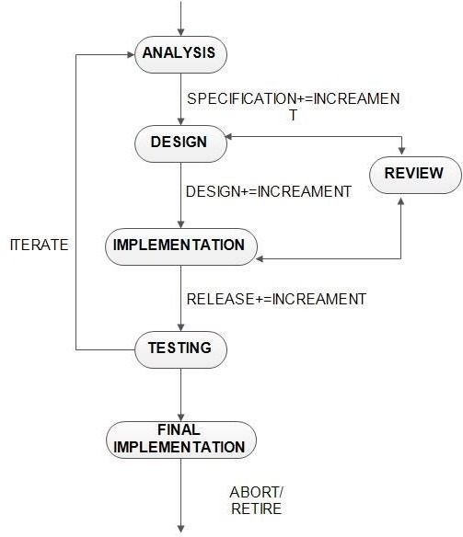

Figure 1.1 Iterative Model

The Iterative Model mentioned above is stated below:-

###### Analysis:-

Analysing the market need and user’s requirement for making it efficient, finding new methods and techniques for making it attractive and user friendly.

###### Designing:-

Designing a website containing different pages for different departments, including slideshows, easy and attractive interface.

###### Implementation:-

The above designing will be implemented in this phase.

###### Testing:-

We will be going to test our project in different environments to check whether we are getting desired results or not.

###### Final Implementation:-

After all iterative process and designing the final implementation will be done.

###### System Maintaience:

**User Registration:-**

There are many fields in user registration page. So there are so many personal details of user which needed to be maintain time to time. There are number of new user to be registered so no. of records are there to be maintain in database.

###### Customer Details:-

We will be going to maintain all these details by the admin. which requires lots of maintenance related to user billing history and new updates.

###### Bill Generation:-

Admin will hold all the bill related information for particular user and these all will be update accordingly in checkout-4 modules.

**ENTITY RELATIONSHIP DIAGRAM**

An Entity Relationship (ER) Diagram is a type of flowchart that illustrates how “entities” such as people, objects or concepts relate to each other within a system. ER Diagrams are most often used to design or debug relational databases in the fields of software engineering, business information systems, education and research. Also known as ERDs

or ER Models, they use a defined set of symbols such as rectangles, diamonds, ovals and connecting lines to depict the interconnectedness of entities, relationships and their attributes. They mirror grammatical structure, with entities as nouns and relationships as verbs.

**DESIGNING**

**SOFTWARE DESIGN**

Software design is a process to transform user requirements into some suitable form, which helps the programmer in software coding and implementation.

For assessing user requirements, an SRS (Software Requirement Specification) document is created whereas for coding and implementation, there is a need of more specific and detailed requirements in software terms. The output of this process can directly be used into implementation in programming languages.

Software design is the first step in SDLC (Software Design Life Cycle), which moves the concentration from problem domain to solution domain. It tries to specify how to fulfill the requirements mentioned in SRS.

## SDLC(SOFTWARE DEVLOPMENT LIFE CYCE)

The software development life cycle (SDLC) is a framework defining tasks performed at each step in the software development process. SDLC is a structure followed by a development team within the software organization. It consists of a detailed plan describing how to develop, maintain and replace specific software. The life cycle defines a methodology for improving the quality of software and the overall development process.

The software development life cycle is also known as the software development process.

SDLC consists of following activities:

1. Planning: The most important parts of software development, requirement gathering or requirement analysis are usually done by the most skilled and experienced software engineers in the organization. After the requirements are gathered from the client, a scope document is created in which the scope of the project is determined and documented.
2. Implementation: The software engineers start writing the code according to the client's requirements.
3. Testing: This is the process of finding defects or bugs in the created software.
4. Documentation: Every step in the project is documented for future reference and for the improvement of the software in the development process. The design documentation may include writing the application programming interface (API).
5. Deployment and maintenance: The software is deployed after it has been approved for release.
6. Maintaining: Software maintenance is done for future reference. Software improvement and new requirements (change requests) can take longer than the time needed to create the initial development of the software.

Software design is a process to conceptualize the software requirements into software implementation. Software design takes the user requirements as challenges and tries to find optimum solution. While the software is being conceptualized, a plan is chalked out to find the best possible design for implementing the intended solution.

There are multiple variants of software design. Let us study them briefly:

## Structured Design

Structured design is a conceptualization of problem into several well-organized elements of solution. It is basically concerned with the solution design. Benefit of structured design is, it gives better understanding of how the problem is being solved. Structured design also makes it simpler for designer to concentrate on the problem more accurately.

Structured design is mostly based on ‘divide and conquer’ strategy where a problem is broken into several small problems and each small problem is individually solved until the whole problem is solved.

The small pieces of problem are solved by means of solution modules. Structured design emphasis that these modules be well organized in order to achieve precise solution.

These modules are arranged in hierarchy. They communicate with each other. A good structured design always follows some rules for communication among multiple modules, namely -

**Cohesion** - grouping of all functionally related elements.

**Coupling** - communication between different modules.

A good structured design has high cohesion and low coupling arrangements.

## Function Oriented Design

In function-oriented design, the system is comprised of many smaller sub-systems known as functions. These functions are capable of performing significant task in the system. The system is considered as top view of all functions.

Function oriented design inherits some properties of structured design where divide and conquer methodology is used.

This design mechanism divides the whole system into smaller functions, which provides means of abstraction by concealing the information and their operation.. These functional modules can share information among themselves by means of information passing and using information available globally.

Another characteristic of functions is that when a program calls a function, the function changes the state of the program, which sometimes is not acceptable by other modules. Function oriented design works well where the system state does not matter and program/functions work on input rather than on a state.

### Design Process

* The whole system is seen as how data flows in the system by means of data flow diagram.
* DFD depicts how functions changes data and state of entire system.
* The entire system is logically broken down into smaller units known as functions on the basis of their operation in the system.
* Each function is then described at large.

**Normalization**

**Normalization** is the process of minimizing **redundancy** from a relation or set of relations. Redundancy in relation may cause insertion, deletion and updation anomalies. So, it helps to minimize the redundancy in relations. **Normal forms** are used to eliminate or reduce redundancy in database tables.

`Decomposing is the process of splitting relations into multiple relations to eliminate anomalies and maintain anomalies and maintain data integrity. To do this we use normal forms or rules for structuring relation.

**Insertion anomaly**:  Inability to add data to the database due to absence of other data.

**Deletion anomaly**:   Unintended loss of data due to deletion of other data.

**Update anomaly**:     Data inconsistency resulting from data redundancy and partial update.

**Normal Forms**:    These are the rules for structuring relations that eliminate anomalies.

**FIRST N0RMAL FORM:**

A relation is said to be in first normal form if the values in the relation are atomic for every attribute in the relation. By this we mean simply that no attribute value can be a set of values or, as it is sometimes expressed, a repeating group.

**SECOND NORMAL FORM**:

A relation is said to be in second Normal form is it is in first normal form and it should satisfy and any one of the following rules.

1)      Primary Key is a not a composite primary key

2)      No non key attributes are present

3)      Every non key attribute is fully fictionally dependent on full set of primary key.

**THIRD NORMAL FORM:**

A relation is said to be in third normal form if their exits no transitive dependencies.

Transitive Dependency:  If two non key attribute depend on each other as well as on the primary key then they are said to be transitively dependent.

The above normalization principles were applied to decompose the data in multiple tables thereby making the data to be maintained in a consistent state.

**E-R DIAGRAM**

An Entity Relationship (ER) Diagram is a type of flowchart that illustrates how “entities” such as people, objects or concepts relate to each other within a system. ER Diagrams are most often used to design or debug relational databases in the fields of software engineering, business information systems, education and research. Also known as ERDs or ER Models, they use a defined set of symbols such as rectangles, diamonds, ovals and connecting lines to depict the interconnectedness of entities, relationships and their attributes. They mirror grammatical structure, with entities as nouns and relationships as verbs.

## Common Entity Relationship Diagram Symbols

An ER diagram is a means of visualizing how the information a system produces is related. There are five main components of an ERD:

* **Entities**, which are represented by rectangles. An entity is an object or concept about which you want to store information.

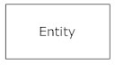

* A weak entity is an entity that must defined by a foreign key relationship with another entity as it cannot be uniquely identified by its own attributes alone.

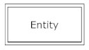

* **Actions**, which are represented by diamond shapes, show how two entities share information in the database. 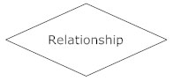In some cases, entities can be self-linked. For example, employees can supervise other employees.  
  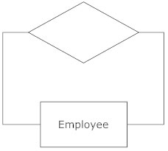
* **Attributes**, which are represented by ovals. A key attribute is the unique, distinguishing characteristic of the entity. For example, an employee's social security number might be the employee's key attribute.   
  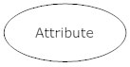
* A multivalued attribute can have more than one value. For example, an employee entity can have multiple skill values.

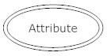

* A derived attribute is based on another attribute. For example, an employee's monthly salary is based on the employee's annual salary.

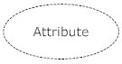

* **Connecting lines**, solid lines that connect attributes to show the relationships of entities in the diagram.
* **Cardinality** specifies how many instances of an entity relate to one instance of another entity. Ordinality is also closely linked to cardinality. While cardinality specifies the occurrences of a relationship, ordinality describes the relationship as either mandatory or optional. In other words, cardinality specifies the maximum number of relationships and ordinality specifies the absolute minimum number of relationships.

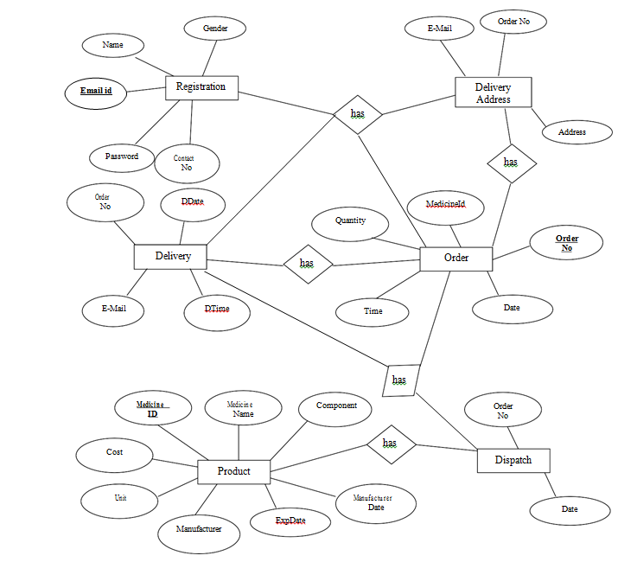

**DATA FLOW DIAGRAMS**

A data flow diagram is graphical tool used to describe and analyze movement of data through a system. These are the central tool and the basis from which the other components are developed. The transformation of data from input to output, through processed, may be described logically and independently of physical components associated with the system. These are known as the logical data flow diagrams. The physical data flow diagrams show the actual implements and movement of data between people, department and workstations. A full description of a system actually consists of a set of data flow diagram. Using two familiar notations Yourdon, Gane and Sarson notation develops the data flow diagrams. Each component in a DFD is labeled with a descriptive name. process is further identified with a number that will be used for identification purpose. The development of DFD’S is done in several levels. Each process in lower level diagrams can be broken down into a more detailed DFD in the next level. The lop- level diagrams is often called context diagram. It consists a single process bit, which plays vital role in studying the current system. The process in the context level diagram is exploded into other process at the first level DFD.

* The idea behind the explosion of a process is that understanding at one level of detail is exploded into greater detail at the next level. This is done until further explosion is necessary and an adequate amount of detail is described for analyst to understand the process.

A DFD consists of a series bubbles joined by data flows in the system .

**DFD SYMBOLS**

In the DFD, there are four symbols.

1.A square defines a source or destination of system data.

2. an arrow identifies data flow.I is the pipeline through which the information flows.

3. A circle or a bubble represents a process that transform incoming data flow and outgoing dataflow.

4. an open rectangle is the data source ,temporary reporistitory of data.

Process that transform data flow.

Source or destination of data

Data flows

Data store

**CONSTRUCTING A DFD**

Sveral rules of thumb are used in drawing DFD’s:

1. Process should be named and numbered for an easy refrences .Each name should be representative of the process.
2. The direction of flow is from tp to bottom and from left to right..data traditionally flow from the source to destination alougth they may flow back to the source .one way indicate this is to draw long flow linl back to the source .
3. When a process is exploded into lower level details, they are numbered .
4. The names of data stores anddestination are written in capital letters . Process and data flows name have the first letter of each work captilized.

A DFD typically shows the minimum contents of data store. Each data store shuld contain all the elements that flow in and out.

Questionaniers should contains all the data elements flow in and out .Missing interface redundancis and like is then accounted for often through interviews.

###### Level 0 DFD:

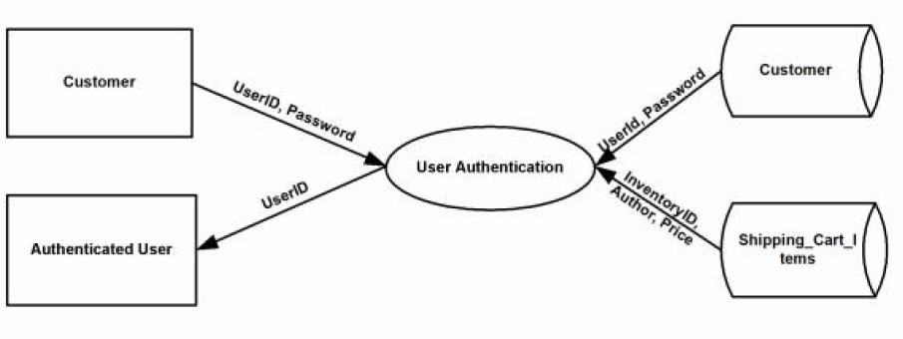**Level 1 DFD:**

###### NUMBER OF MODULE

**Administration :** In this Project has an administration level that the administration can add, update, and can also check view booked orders for dispatch.

**User Registration :** User registration is a module, where users can get register themselves.

**Login :** login is the procedure used to get access during purchase medicines.

**Online :** This is the gateway through which any one can purchase all types of medicine.

**Dispatching :** Dispatching is a procedure for assigning orders to the customers.

**Delivery :** Delivery is the process of transporting medicines from a source location to a shipping destination.

CODING

###### Source Code

###### Index.php

###### <html>

###### <head>

###### 

###### </head>

###### <body class="body">

###### <div class="container-fluid">

###### <div class="col-md-10 col-md-offset-1" style="box-shadow:0px 0px 40px #000">

###### <?php include "header.php"; ?>

###### 

###### <div class="row" style="padding-top:10px">

###### <div class="col-md-8">

###### <div id="myCarousel" class="carousel slide" data-ride="carousel">

###### <!-- Indicators -->

###### <ol class="carousel-indicators">

###### <li data-target="#myCarousel" data-slide-to="0" class="active"></li>

###### <li data-target="#myCarousel" data-slide-to="1"></li>

###### <li data-target="#myCarousel" data-slide-to="2"></li>

###### <li data-target="#myCarousel" data-slide-to="3"></li>

###### </ol>

###### <!-- Wrapper for slides -->

###### <div class="carousel-inner">

###### <div class="item active">

###### <img src="img/m4.jpg" style="width:100%;">

###### </div>

###### <div class="item">

###### <img src="img/m2.jpg"style="width:100%;">

###### </div>

###### 

###### <div class="item">

###### <img src="img/m1.jpg" style="width:100%;">

###### </div>

###### <div class="item">

###### <img src="img/m3.jpg" style="width:100%;">

###### </div>

###### </div>

###### <!-- Left and right controls -->

###### <a class="left carousel-control" href="#myCarousel" data-slide="prev">

###### <span class="glyphicon glyphicon-chevron-left"></span>

###### <span class="sr-only">Previous</span>

###### </a>

###### <a class="right carousel-control" href="#myCarousel" data-slide="next">

###### <span class="glyphicon glyphicon-chevron-right"></span>

###### <span class="sr-only">Next</span>

###### </a>

###### </div>

###### </div>

###### <div class="col-md-4" style="padding-top:0px">

###### <div class="panel panel-danger">

###### <div class="panel-heading">

###### <p><b>Choose Category</b></p>

###### </div>

###### <div class="panel-body">

###### <ul>

###### <li><a href="pain.php">Pain</a></li>

###### <li><a href="skin_care.php">Skin Care</a></li>

###### <li><a href="eye_care.php">Eye Care</a></li>

###### <li><a href="worm.php">Worm</a></li>

###### <li><a href="depression.php">Depression</a></li>

###### </ul>

###### </div>

###### </div>

###### 

###### <div class="panel panel-success">

###### <div class="panel-heading">

###### <p><b>Latest Medicine & Offers</b></p>

###### </div>

###### <div class="panel-body" style="height:115px">

###### <marquee direction="up" scrollamount="3" height="100%">

###### <p>20% of all Vitamin Medicine for New Customers</p>

###### </marquee>

###### </div>

###### </div>

###### </div>

###### </div>

###### 

###### <div class="row" style="padding-top:10px">

###### <div class="col-md-12">

###### <div class="panel panel-success">

###### <div class="panel-heading">

###### <h3>Featured Product</h3>

###### </div>

###### <div class="panel-body">

###### <?php include "dbconnect.php";

###### $q="select *from medicine";

###### $qu=mysql_query($q);

###### while($rs=mysql_fetch_assoc($qu))

###### {?>

###### <form method="post" action="order_now.php">

###### 

###### <div class="col-md-2" align="center">

###### <input type="text" name="t1" value="<?php echo $rs['name']; ?>" style="display:none">

###### <?php echo '<img src="product/'.$rs['img'].'" style="width:100%; height:130px"">'; ?><br> <b>Price <?php echo $rs['price']; ?>/-</b>

###### <div class="col-md-12" style="background:#F00" align="center">

###### <input type="submit" value="Order Now" class="btn btn-link">

###### </div>

###### </div>

###### </form>

###### <?php }

###### ?>

###### </div>

###### </div>

###### </div>

###### </div>

###### <?php include "footer.php"; ?>

###### </div>

###### </div>

###### </body>

###### </html>

**About.php**

<html>

<head>

</head>

<body class="body">

<div class="container-fluid">

<div class="col-md-10 col-md-offset-1" style="box-shadow:0px 0px 40px #000">

<?php include "header.php"; ?>

<div class="row" style="padding-top:10px">

<div class="col-md-12">

<div class="panel panel-warning">

<div class="panel-heading">

<p>About Us</p>

</div>

<div class="panel-body">

<p>

“Online Medicine Store” Site is a tool which is used in the automation of Medicine Selection and Purchase in an Online. In this tool, the medicine will be automated, Searched and Purchased by the customers dynamically and the reports on the same.

</p><p>

The proposed system of Online Medicine Store Site is fully an automated one. In the proposed Shopping Site, the customer in online can view the Medicine and requirements put forward by them. Online Medicine purchase is also possible with this system. As the proposed system is a centralized one, redundancy can be avoided; moreover the coordination of different departments becomes much easier.

</p><p>

The online interaction between Customers and administrator is also possible. The administrator is the one who is adding all the medicine details either through online or in direct for editing medicine day by day manner. The present era is technically far advanced. With the rapid growth in technology, the life style of a human being is changing on a very high pace. This advanced technology provides an average human being with opportunity of leading a comfortable life.

</p><p>

The E medicine system enables vendors to set up online shops for medicine, and also helps customers to buy medicine online , and a system administrator to approve and reject requests for new medicial store and maintain lists of store categories.Also on the agenda is designing an E-medicial site to manage the items in the shop and also help customers purchase them online without having to visit the medicine store physically.Our online E medical store will use the internet as the sole method for selling medicine to its consumers. Buying will be highly personalized and the items will provides at lower prices than most competitors.

</p>

</div>

</div>

</div>

</div>

<?php include "footer.php"; ?>

</div>

</div>

</body>

</html>

**Contact.php**

<html>

<head>

</head>

<body class="body">

<div class="container-fluid">

<div class="col-md-10 col-md-offset-1" style="box-shadow:0px 0px 40px #000">

<?php include "header.php"; ?>

<div class="row" style="padding-top:10px">

<div class="col-md-6">

<div class="panel panel-info">

<div class="panel-heading" align="center">

<h3>Quick Enquiry</h3>

</div>

<div class="panel-body">

<form method="post" action="contact_action.php">

<label for="">Name *</label>

<input type="text" name="t1" pattern="[A-Za-z ]{4,}" class="form-control" placeholder="Plz Enter Name *" required title="Only Letter and White Space Allowed">

<label for="">Mobile No. *</label>

<input type="text" name="t2" pattern="[0-9]{10}" class="form-control" placeholder="Plz Enter Mobile No. *" required title="Only Numbers allowed..">

<label for="">Email ID *</label>

<input type="email" name="t3" class="form-control" placeholder="Plz Enter Email ID *" required>

<label for="">Message *</label>

<textarea placeholder="Plz Enter Message....." class="form-control" name="t4" rows="4" required></textarea><br>

<input type="submit" value="Submit" class="btn btn-group-justified btn-danger">

</form>

</div>

</div>

</div>

<div class="col-md-6">

<div class="panel panel-danger">

<div class="panel-heading" align="center">

<h3>Contact Info</h3>

</div>

<div class="panel-body">

<div class="col-md-8 col-md-offset-2">

<img src="img/pd.jpg" class="img-responsive"><br>

<p><strong>Name :- </strong>Shashi Shekhar Suman</p>

<p><strong>Email ID :- </strong>shekharsumanshashi@gmail.com</p>

<p><strong>Mobile No. :- </strong>7209794742</p>

</div>

</div>

</div>

</div>

</div>

<div class="row">

<div class="col-md-8 col-md-offset-2">

<img src="img/map.PNG" class="img-responsive">

</div>

</div>

<?php include "footer.php"; ?>

</div>

</div>

</body>

</html>

**Contact_action.php**

<html>

<head>

</head>

<body class="body">

<div class="container-fluid">

<div class="col-md-10 col-md-offset-1" style="box-shadow:0px 0px 40px #000">

<?php include "header.php"; ?>

<div class="row" style="padding-top:10px">

<div class="col-md-12">

<?php

include "dbconnect.php";

$a=$_REQUEST['t1'];

$b=$_REQUEST['t2'];

$c=$_REQUEST['t3'];

$d=$_REQUEST['t4'];

$q="insert into enquiry(name,email,phone,message) values('$a','$c','$b','$d')";

mysql_query($q);

?>

<h3>Thank You ! <br>Your Message has been send we will contact within 24 Hours...</h3>

</div>

</div>

<?php include "footer.php"; ?>

</div>

</div>

</body>

</html>

**Header.php**

<!DOCTYPE html>

<html lang="en">

<head>

<style type="text/css">

.body

{

background:#FFF;

}

</style>

<title>E-Medicine</title>

<meta charset="utf-8">

<link rel="stylesheet" href="https://maxcdn.bootstrapcdn.com/bootstrap/3.3.7/css/bootstrap.min.css">

<meta name="viewport" content="width=device-width, initial-scale=1">

<script src="https://ajax.googleapis.com/ajax/libs/jquery/3.3.1/jquery.min.js"></script>

<script src="https://maxcdn.bootstrapcdn.com/bootstrap/3.3.7/js/bootstrap.min.js"></script>

<link rel="stylesheet" href="https://cdnjs.cloudflare.com/ajax/libs/font-awesome/4.7.0/css/font-awesome.min.css">

<style>

.fa {

padding: 10px;

font-size: 20px;

width: 40px;

height:40px;

text-align: center;

text-decoration: none;

border-radius:50%;

}

.fa:hover {

opacity: 0.7;

}

.fa-facebook {

background: #3B5998;

color: white;

}

.fa-twitter {

background: #55ACEE;

color: white;

}

.fa-google {

background: #dd4b39;

color: white;

}

.c li a

{

color:#FFF;

text-transform:capitalize;

}

.c li a:hover

{

color:#FFF;

text-transform:capitalize;

}

.d li a

{

color:#fff;

text-transform:capitalize;

background:#999;

}

</style>

</head>

<body>

<div class="row" style="background:#F00">

<div class="col-md-4 col-xs-12">

<p style="color:#fff; padding-top:5px;">

<a href="index.php"><img src="img/medicine logo.png" class="img-responsive"></a>

</p>

</div>

<div class="col-md-4"></div>

<div class="col-md-4" align="center" style="padding-top:10px">

<span class="glyphicon glyphicon-phone-alt" style="color:#fff; font-size:20px"> 7209794742</span>

<div class="col-md-12" style="padding-top:10px">

<a href="#" class="fa fa-facebook"></a>

<a href="#" class="fa fa-twitter"></a>

<a href="#" class="fa fa-google"></a>

</div>

</div>

</div>

<div class="row" style="padding-top:5px">

<div class="col-md-12 col-xs-12" style="background:#999">

<nav class="">

<div class="container-fluid">

<div class="navbar-header">

<button type="button" class="navbar-toggle" data-toggle="collapse" data-target="#myNavbar">

<span class="glyphicon glyphicon-align-justify" style="color:#fff"></span>

</button>

</div>

<div class="collapse navbar-collapse" id="myNavbar">

<ul class="nav navbar-nav c">

<li class="active"><a href="index.php"><span class="glyphicon glyphicon-home"></span> Home</a></li>

<li><a href="about.php"><span class="glyphicon glyphicon-pencil"></span> About</a></li>

<li class="dropdown">

<a class="dropdown-toggle" data-toggle="dropdown" href="#"><span class="glyphicon glyphicon-briefcase"></span> Medicine <span class="caret"></span></a>

<ul class="dropdown-menu d">

<li><a href="pain.php">Pain</a></li>

<li><a href="skin_care.php">Skin Care</a></li>

<li><a href="eye_care.php">Eye Care</a></li>

<li><a href="worm.php">Worm</a></li>

<li><a href="depression.php">Depression</a></li>

</ul>

</li>

<li><a href="contact.php"><span class="glyphicon glyphicon-phone-alt"></span> Contact</a></li>

</ul>

<ul class="nav navbar-nav navbar-right c">

<li><a href="admin_login.php"><span class="glyphicon glyphicon-log-in"></span> Admin Login</a></li>

</ul>

</div>

</div>

</nav>

</div>

</div>

</body>

</html>

**Footer.php**

<html>

<head>

</head>

<body>

<div class="row" style="background:#9CF; color:#f00">

<div class="col-md-4">

<h4>Contact Us</h4>

<p><span class="glyphicon glyphicon-phone-alt"></span> 7209794742</p>

<p><span class="glyphicon glyphicon-envelope"></span> shekharsumanshashi@gmail.com</p>

</div>

<div class="col-md-4">

<h4>To Buy</h4>

<p><span class="glyphicon glyphicon-phone-alt"></span> 7209794742</p>

<p><span class="glyphicon glyphicon-envelope"></span> shekharsumanshashi@gmail.com</p>

<p>Delevery - Free Home Delevery</p>

<p>Payment - Cash On Delevery <b>(COD)</b></p>

</div>

<div class="col-md-4">

<iframe src="http://www.facebook.com/plugins/likebox.php?href=http%3A%2F%2Fwww.facebook.com%2F177553366270714&width=300px&colorscheme=light&show_faces=true&border_color&stream=true&header=true&height=200" scrolling="yes" frameborder="0" style="border:none; overflow:hidden; width:100%; height:230px; background:; float:left; " allowtransparency="true"></iframe>

</div>

</div>

<div class="row" style="background:#C00; color:#fff">

<div class="col-md-6">

<h4>Copyright &copy; 2018 E-Medicalwala. All Right Reserved.</h4>

</div>

<div class="col-md-6" align="right">

<h4>Developed & Design By : Shashi Shekhar Suman</h4>

</div>

</div>

</body>

</html>

**Pain.php**

<html>

<head>

</head>

<body class="body">

<div class="container-fluid">

<div class="col-md-10 col-md-offset-1" style="box-shadow:0px 0px 40px #000">

<?php include "header.php"; ?>

<div class="row" style="padding-top:10px">

<div class="col-md-12">

<div class="panel panel-info">

<div class="panel-heading" align="center">

<h3>Medicine of Pain</h3>

</div>

<div class="panel-body">

<?php include "dbconnect.php";

$q="select *from medicine where type='Pain'";

$qu=mysql_query($q);

while($rs=mysql_fetch_assoc($qu))

{?>

<form method="post" action="order_now.php">

<div class="col-md-2" align="center">

<input type="text" name="t1" value="<?php echo $rs['name']; ?>" style="display:none">

<?php echo '<img src="product/'.$rs['img'].'" style="width:100%; height:130px"">'; ?><br> <b>Price <?php echo $rs['price']; ?>/-</b>

<div class="col-md-12" style="background:#F00" align="center">

<input type="submit" value="Order Now" class="btn btn-link">

</div>

</div>

</form>

<?php }

?>

</div>

</div>

</div>

</div>

<?php include "footer.php"; ?>

</div>

</div>

</body>

</html>

**Skin_care.php**

<html>

<head>

</head>

<body class="body">

<div class="container-fluid">

<div class="col-md-10 col-md-offset-1" style="box-shadow:0px 0px 40px #000">

<?php include "header.php"; ?>

<div class="row" style="padding-top:10px">

<div class="col-md-12">

<div class="panel panel-info">

<div class="panel-heading" align="center">

<h3>Medicine of Skin care</h3>

</div>

<div class="panel-body">

<?php include "dbconnect.php";

$q="select *from medicine where type='Skin Care'";

$qu=mysql_query($q);

while($rs=mysql_fetch_assoc($qu))

{?>

<form method="post" action="order_now.php">

<div class="col-md-2" align="center">

<input type="text" name="t1" value="<?php echo $rs['name']; ?>" style="display:none">

<?php echo '<img src="product/'.$rs['img'].'" style="width:100%; height:130px"">'; ?><br> <b>Price <?php echo $rs['price']; ?>/-</b>

<div class="col-md-12" style="background:#F00" align="center">

<input type="submit" value="Order Now" class="btn btn-link">

</div>

</div>

</form>

<?php }

?>

</div>

</div>

</div>

</div>

<?php include "footer.php"; ?>

</div>

</div>

</body>

</html>

**Eye_care.php**

<html>

<head>

</head>

<body class="body">

<div class="container-fluid">

<div class="col-md-10 col-md-offset-1" style="box-shadow:0px 0px 40px #000">

<?php include "header.php"; ?>

<div class="row" style="padding-top:10px">

<div class="col-md-12">

<div class="panel panel-info">

<div class="panel-heading" align="center">

<h3>Medicine of Eye care</h3>

</div>

<div class="panel-body">

<?php include "dbconnect.php";

$q="select *from medicine where type='Eye Care'";

$qu=mysql_query($q);

while($rs=mysql_fetch_assoc($qu))

{?>

<form method="post" action="order_now.php">

<div class="col-md-2" align="center">

<input type="text" name="t1" value="<?php echo $rs['name']; ?>" style="display:none">

<?php echo '<img src="product/'.$rs['img'].'" style="width:100%; height:130px"">'; ?><br> <b>Price <?php echo $rs['price']; ?>/-</b>

<div class="col-md-12" style="background:#F00" align="center">

<input type="submit" value="Order Now" class="btn btn-link">

</div>

</div>

</form>

<?php }

?>

</div>

</div>

</div>

</div>

<?php include "footer.php"; ?>

</div>

</div>

</body>

</html>

**Worm.php**

<html>

<head>

</head>

<body class="body">

<div class="container-fluid">

<div class="col-md-10 col-md-offset-1" style="box-shadow:0px 0px 40px #000">

<?php include "header.php"; ?>

<div class="row" style="padding-top:10px">

<div class="col-md-12">

<div class="panel panel-info">

<div class="panel-heading" align="center">

<h3>Medicine of Worm</h3>

</div>

<div class="panel-body">

<?php include "dbconnect.php";

$q="select *from medicine where type='Worm'";

$qu=mysql_query($q);

while($rs=mysql_fetch_assoc($qu))

{?>

<form method="post" action="order_now.php">

<div class="col-md-2" align="center">

<input type="text" name="t1" value="<?php echo $rs['name']; ?>" style="display:none">

<?php echo '<img src="product/'.$rs['img'].'" style="width:100%; height:130px"">'; ?><br> <b>Price <?php echo $rs['price']; ?>/-</b>

<div class="col-md-12" style="background:#F00" align="center">

<input type="submit" value="Order Now" class="btn btn-link">

</div>

</div>

</form>

<?php }

?>

</div>

</div>

</div>

</div>

<?php include "footer.php"; ?>

</div>

</div>

</body>

</html>

**Depression.php**

<html>

<head>

</head>

<body class="body">

<div class="container-fluid">

<div class="col-md-10 col-md-offset-1" style="box-shadow:0px 0px 40px #000">

<?php include "header.php"; ?>

<div class="row" style="padding-top:10px">

<div class="col-md-12">

<div class="panel panel-info">

<div class="panel-heading" align="center">

<h3>Medicine of Depression</h3>

</div>

<div class="panel-body">

<?php include "dbconnect.php";

$q="select *from medicine where type='Depression'";

$qu=mysql_query($q);

while($rs=mysql_fetch_assoc($qu))

{?>

<form method="post" action="order_now.php">

<div class="col-md-2" align="center">

<input type="text" name="t1" value="<?php echo $rs['name']; ?>" style="display:none">

<?php echo '<img src="product/'.$rs['img'].'" style="width:100%; height:130px"">'; ?><br> <b>Price <?php echo $rs['price']; ?>/-</b>

<div class="col-md-12" style="background:#F00" align="center">

<input type="submit" value="Order Now" class="btn btn-link">

</div>

</div>

</form>

<?php }

?>

</div>

</div>

</div>

</div>

<?php include "footer.php"; ?>

</div>

</div>

</body>

</html>

**Order_now.pho**

<?php session_start(); ?>

<html>

<head>

</head>

<body class="body">

<div class="container-fluid">

<div class="col-md-10 col-md-offset-1" style="box-shadow:0px 0px 40px #000">

<?php include "header.php"; ?>

<div class="row" style="padding-top:10px">

<div class="col-md-12">

<div class="panel panel-warning">

<div class="panel-heading">

<p>Order Details</p>

</div>

<div class="panel-body">

<div class="col-md-4"></div>

<div class="col-md-4">

<?php

include "dbconnect.php";

$a=$_REQUEST['t1'];

$q="select *from medicine where name='$a'";

$qu=mysql_query($q);

$rs=mysql_fetch_assoc($qu);

$_SESSION['m_name']=$rs['name'];

$_SESSION['m_price']=$rs['price'];

$_SESSION['m_type']=$rs['type'];

?>

<form method="post" action="order_now_action.php">

<label for="">Medicine Name</label>

<input type="text" name="t1" class="form-control" value="<?php echo $_SESSION['m_name']; ?>" readonly>

<label for="">Medicine Price</label>

<input type="text" name="t2" class="form-control" value="<?php echo $_SESSION['m_price']; ?>" readonly>

<label for="">Medicine Type</label>

<input type="text" name="t3" class="form-control" value="<?php echo $_SESSION['m_type']; ?>" readonly>

<label for="">Enter Quantity</label>

<input type="text" name="t4" title="Plz enter only Numbers..." pattern="[0-9]{1,}" required class="form-control">

<br><input type="submit" value="Proceed" class="btn btn-group-justified btn-success">

</form>

</div>

<div class="col-md-4"></div>

</div>

</div>

</div>

</div>

<?php include "footer.php"; ?>

</div>

</div>

</body>

</html>

**Order_now_action.php**

<?php session_start(); ?>

<html>

<head>

</head>

<body class="body">

<div class="container-fluid">

<div class="col-md-10 col-md-offset-1" style="box-shadow:0px 0px 40px #000">

<?php include "header.php"; ?>

<div class="row" style="padding-top:10px">

<div class="col-md-12">

<div class="panel panel-warning">

<div class="panel-heading">

<p>Order Details</p>

</div>

<div class="panel-body">

<div class="col-md-4"></div>

<div class="col-md-4">

<?php

include "dbconnect.php";

$a=$_REQUEST['t4'];

$b=$_SESSION['m_price'];

$_SESSION['qu']=$a;

$_SESSION['amount']=$a*$b;

?>

<form method="post" action="billing.php">

<label for="">Medicine Name</label>

<input type="text" name="t1" class="form-control" value="<?php echo $_SESSION['m_name']; ?>" readonly>

<label for="">Medicine Price</label>

<input type="text" name="t2" class="form-control" value="<?php echo $_SESSION['m_price']; ?>" readonly>

<label for="">Medicine Type</label>

<input type="text" name="t3" class="form-control" value="<?php echo $_SESSION['m_type']; ?>" readonly>

<label for="">Quantity</label>

<input type="text" name="t4" class="form-control" value="<?php echo $_SESSION['qu']; ?>" readonly>

<label for="">Total Amount</label>

<input type="text" name="t5" value="<?php echo $_SESSION['amount']; ?>" readonly class="form-control">

<br><input type="submit" value="Purchase" class="btn btn-group-justified btn-success">

</form>

</div>

<div class="col-md-4"></div>

</div>

</div>

</div>

</div>

<?php include "footer.php"; ?>

</div>

</div>

</body>

</html>

**Billing.php**

<?php session_start(); ?>

<html>

<head>

</head>

<body class="body">

<div class="container-fluid">

<div class="col-md-10 col-md-offset-1" style="box-shadow:0px 0px 40px #000">

<?php include "header.php";

?>

<div class="row" style="padding-top:10px">

<div class="col-md-12">

<div class="panel panel-info">

<div class="panel-heading">

<p>Login OR Register Your Self</p>

</div>

<div class="panel-body">

<div class="col-md-4"></div>

<div class="col-md-4">

<?php

if(isset($_POST['login']))

{

include "dbconnect.php";

$a=$_POST['l1'];

$b=$_POST['l2'];

$c="select *from register where email='$a'";

$d=mysql_query($c);

$e=mysql_fetch_assoc($d);

$dp=$e['password'];

if($dp==$b)

{

$_SESSION['m_name'];

$_SESSION['m_price'];

$_SESSION['m_type'];

$_SESSION['amount'];

$_SESSION['u_name']=$e['name'];

$_SESSION['u_email']=$e['email'];

$_SESSION['u_phone']=$e['phone'];

$_SESSION['add']=$e['address'];

$_SESSION['qu'];

header("location:after_login_billing.php");

}

}

?>

<form method="post">

<label for="">Username (Email ID)</label>

<input type="text" name="l1" class="form-control" required>

<label for="">Password</label>

<input type="password" name="l2" class="form-control" required>

<br><input type="submit" name="login" value="Login" class="btn btn-group-justified btn-info">

<br><p><b>Not a Member ? <a href="register.php">Register Here</a></b></p>

</form>

</div>

<div class="col-md-4"></div>

</div>

</div>

</div>

</div>

<?php include "footer.php"; ?>

</div>

</div>

</body>

</html>

**Register.php**

<?php session_start(); ?>

<html>

<head>

</head>

<body class="body">

<div class="container-fluid">

<div class="col-md-10 col-md-offset-1" style="box-shadow:0px 0px 40px #000">

<?php include "header.php";

$_SESSION['m_name'];

$_SESSION['m_price'];

$_SESSION['m_type'];

$_SESSION['amount'];

$_SESSION['qu'];

?>

<div class="row" style="padding-top:10px">

<div class="col-md-12">

<div class="panel panel-success">

<div class="panel-heading">

<p>Customer's Registration Form</p>

</div>

<div class="panel-body">

<div class="col-md-4"></div>

<div class="col-md-4">

<form method="post" action="register_action.php">

<label for="">Name</label>

<input type="text" name="t1" class="form-control" required>

<label for="">Email ID</label>

<input type="email" name="t2" class="form-control" required>

<label for="">Mobile No.</label>

<input type="text" name="t3" class="form-control" pattern="[0-9]{10}" required>

<label for="">Address</label>

<textarea rows="3" class="form-control" name="t4"></textarea>

<br><input type="submit" value="Register" class="btn btn-group-justified btn-info">

</form>

</div>

<div class="col-md-4"></div>

</div>

</div>

</div>

</div>

<?php include "footer.php"; ?>

</div>

</div>

</body>

</html>

**Register_action.php**

<?php session_start(); ?>

<html>

<head>

</head>

<body class="body">

<div class="container-fluid">

<div class="col-md-10 col-md-offset-1" style="box-shadow:0px 0px 40px #000">

<?php include "header.php";

$_SESSION['m_name'];

$_SESSION['m_price'];

$_SESSION['m_type'];

$_SESSION['amount'];

$_SESSION['qu'];

?>

<div class="row" style="padding-top:10px">

<div class="col-md-12">

<div class="panel panel-success">

<div class="panel-heading">

<p>Customer's Registration Success</p>

</div>

<div class="panel-body">

<div class="col-md-2"></div>

<div class="col-md-8">

<?php

include "dbconnect.php";

$a=$_REQUEST['t1'];

$b=$_REQUEST['t2'];

$c=$_REQUEST['t3'];

$d=$_REQUEST['t4'];

$e=md5($b);

$f=substr($e,1,6);

$g="insert into register(name,email,phone,address,password) values('$a','$b','$c','$d','$f')";

mysql_query($g);

?>

<h4>Your Username : <span style="color:#f00"><?php echo $b; ?></span></h4>

<h4>Your Password : <span style="color:#f00"><?php echo $f; ?></span></h4>

<p><strong>You Want to Login <a href="billing.php">Click Here</a></strong></p>

</div>

<div class="col-md-2"></div>

</div>

</div>

</div>

</div>

<?php include "footer.php"; ?>

</div>

</div>

</body>

</html>

**After_login_billing.php**

<?php session_start(); ?>

<html>

<head>

</head>

<body class="body">

<div class="container-fluid">

<div class="col-md-10 col-md-offset-1" style="box-shadow:0px 0px 40px #000">

<?php include "header.php";

?>

<div class="row" style="padding-top:10px">

<div class="col-md-12">

<div class="panel panel-info">

<div class="panel-heading">

<p>Complete your payment</p>

</div>

<div class="panel-body">

<div class="col-md-4"></div>

<div class="col-md-4">

<form method="post" action="payment.php">

<label for="">Customer's Name</label>

<input type="text" name="t1" class="form-control" value="<?php echo $_SESSION['u_name']; ?>" readonly>

<label for="">Customer's Email ID</label>

<input type="text" name="t2" class="form-control" value="<?php echo $_SESSION['u_email']; ?>" readonly>

<label for="">Customer's Phone No.</label>

<input type="text" name="t3" value="<?php echo $_SESSION['u_phone']; ?>" readonly class="form-control">

<label for="">Customer's Address</label>

<input type="text" name="t4" value="<?php echo $_SESSION['add']; ?>" readonly class="form-control">

<label for="">Medicine Name</label>

<input type="text" name="t5" class="form-control" value="<?php echo $_SESSION['m_name']; ?>" readonly>

<label for="">Medicine Price</label>

<input type="text" name="t6" class="form-control" value="<?php echo $_SESSION['m_price']; ?>" readonly>

<label for="">Medicine Type</label>

<input type="text" name="t7" class="form-control" value="<?php echo $_SESSION['m_type']; ?>" readonly>

<label for="">Quantity</label>

<input type="text" name="t8" class="form-control" value="<?php echo $_SESSION['qu']; ?>" readonly>

<label for="">Total Amount</label>

<input type="text" name="t9" value="<?php echo $_SESSION['amount']; ?>" readonly class="form-control">

<br><input type="submit" value="Proceed to Payment" class="btn btn-group-justified btn-success">

</form>

</div>

<div class="col-md-4"></div>

</div>

</div>

</div>

</div>

<?php include "footer.php"; ?>

</div>

</div>

</body>

</html>

**Payment.php**

<?php session_start(); ?>

<html>

<head>

</head>

<body class="body">

<div class="container-fluid">

<div class="col-md-10 col-md-offset-1" style="box-shadow:0px 0px 40px #000">

<?php include "header.php";

?>

<div class="row" style="padding-top:10px">

<div class="col-md-12">

<div class="panel panel-info">

<div class="panel-heading">

<p>Complete your payment</p>

</div>

<div class="panel-body">

<div class="col-md-8 col-md-offset-2">

<img src="img/payumoney.png" class="img-responsive"><br>

<?php

include "dbconnect.php";

$a=$_REQUEST['t1'];$b=$_REQUEST['t2'];$c=$_REQUEST['t3'];

$d=$_REQUEST['t4'];$e=$_REQUEST['t5'];$f=$_REQUEST['t6'];

$g=$_REQUEST['t7'];$h=$_REQUEST['t8'];$i=$_REQUEST['t9'];

$q="insert into book(name,email,phone,address,medicine,quantity,amount) values('$a','$b','$c','$d','$e','$h','$i')";

mysql_query($q);

?>

</div>

<div class="col-md-4"></div>

<div class="col-md-4">

<form method="post">

<label for="">Amount </label>

<input type="text" name="t1" class="form-control" value="<?php echo $_SESSION['amount']; ?>" readonly>

<label for="">Card No.</label>

<input type="text" class="form-control">

<label for="">Card Holder's Name</label>

<input type="text" class="form-control">

<label for="">CVV No.</label>

<input type="password" class="form-control">

<label for="">Expairy Date</label><br>

<select>

<option>Select...</option>

<option>01</option>

<option>02</option>

<option>03</option>

<option>04</option>

<option>05</option>

<option>06</option>

<option>07</option>

<option>08</option>

<option>09</option>

<option>10</option><option>11</option><option>12</option>

</select> &nbsp;&nbsp;&nbsp;&nbsp;&nbsp;<select>

<option>Select...</option>

<option>2018</option>

<option>2019</option>

<option>2020</option>

<option>2021</option>

<option>2022</option>

<option>2023</option>

<option>2024</option>

<option>2026</option>

<option>2027</option>

<option>2028</option>

</select><br>

<br><input type="submit" disabled class="btn btn-group-justified btn-success" value="Pay Now">

</form>

</div>

<div class="col-md-4"></div>

</div>

</div>

</div>

</div>

<?php include "footer.php"; ?>

</div>

</div>

</body>

</html>

**Admin_login.php**

<?php session_start(); ?>

<html>

<head>

</head>

<body class="body">

<div class="container-fluid">

<div class="col-md-10 col-md-offset-1" style="box-shadow:0px 0px 40px #000">

<?php include "header.php"; ?>

<div class="row" style="padding-top:10px">

<div class="col-md-6 col-md-offset-3">

<div class="panel panel-info">

<div class="panel-heading" align="center">

<h3>Admin Login</h3>

</div>

<?php

$er=$er1=$er2="";

if(isset($_POST['log']))

{

include "dbconnect.php";

$a=$_POST['t1'];

$b=$_POST['t2'];

if($a=="")

{

$er1="Username is required..";

}

if($b=="")

{

$er2="Password is Required...";

}

if($a!="" AND $b!="")

{

$c="select *from admin where username='$a'";

$d=mysql_query($c);

$e=mysql_fetch_assoc($d);

$dp=$e['password'];

if($b==$dp)

{

$_SESSION['log']=true;

$_SESSION['name']=$e['name'];

header("location:admin_panel.php");

}

else

{

$er="Username & Password is Incorrect...";

}

}

}

?>

<div class="panel-body">

<form method="post">

<p style="color:f00"><?php echo $er; ?></p>

<label for="">Username <span style="color:#F00">* <?php echo $er1; ?></span></label>

<input type="text" name="t1" placeholder="Plz Enter Username *" class="form-control">

<label for="">Password <span style="color:#F00">* <?php echo $er2; ?></span></label>

<input type="password" name="t2" placeholder="Plz Enter Password *" class="form-control"><br>

<input type="submit" name="log" value="Login" class="btn btn-group-justified btn-success">

</form>

</div>

</div>

</div>

</div>

<?php include "footer.php"; ?>

</div>

</div>

</body>

</html>

**Admin_panel.php**

<?php session_start();

if(!empty($_SESSION['log']))

{

?>

<html>

<head>

</head>

<body class="body">

<div class="container-fluid">

<div class="col-md-10 col-md-offset-1" style="box-shadow:0px 0px 40px #000">

<?php include "header1.php"; ?>

<div class="row" style="padding-top:10px">

</div>

<?php include "footer.php"; ?>

</div>

</div>

</body>

</html>

<?php

}

else

{

header("location:index.php");

}

?>

**Header1.php**

<!DOCTYPE html>

<html lang="en">

<head>

<style type="text/css">

.body

{

background:#FFF;

}

</style>

<title>E-Medicine</title>

<meta charset="utf-8">

<link rel="stylesheet" href="https://maxcdn.bootstrapcdn.com/bootstrap/3.3.7/css/bootstrap.min.css">

<meta name="viewport" content="width=device-width, initial-scale=1">

<script src="https://ajax.googleapis.com/ajax/libs/jquery/3.3.1/jquery.min.js"></script>

<script src="https://maxcdn.bootstrapcdn.com/bootstrap/3.3.7/js/bootstrap.min.js"></script>

<link rel="stylesheet" href="https://cdnjs.cloudflare.com/ajax/libs/font-awesome/4.7.0/css/font-awesome.min.css">

<style>

.fa {

padding: 10px;

font-size: 20px;

width: 40px;

height:40px;

text-align: center;

text-decoration: none;

border-radius:50%;

}

.fa:hover {

opacity: 0.7;

}

.fa-facebook {

background: #3B5998;

color: white;

}

.fa-twitter {

background: #55ACEE;

color: white;

}

.fa-google {

background: #dd4b39;

color: white;

}

.c li a

{

color:#FFF;

text-transform:capitalize;

}

.c li a:hover

{

color:#FFF;

text-transform:capitalize;

}

.d li a

{

color:#fff;

text-transform:capitalize;

background:#999;

}

</style>

</head>

<body>

<div class="row" style="background:#F00">

<div class="col-md-4 col-xs-12">

<p style="color:#fff; padding-top:5px;">

<a href="admin_panel.php"><img src="img/medicine logo.png" class="img-responsive"></a>

</p>

</div>

<div class="col-md-4"></div>

<div class="col-md-4" align="center" style="padding-top:10px">

<span class="glyphicon glyphicon-phone-alt" style="color:#fff; font-size:20px"> 7209794742</span>

<div class="col-md-12" style="padding-top:10px">

<a href="#" class="fa fa-facebook"></a>

<a href="#" class="fa fa-twitter"></a>

<a href="#" class="fa fa-google"></a>

</div>

</div>

</div>

<div class="row" style="padding-top:5px">

<div class="col-md-12 col-xs-12" style="background:#999">

<nav class="">

<div class="container-fluid">

<div class="navbar-header">

<button type="button" class="navbar-toggle" data-toggle="collapse" data-target="#myNavbar">

<span class="glyphicon glyphicon-align-justify" style="color:#fff"></span>

</button>

</div>

<div class="collapse navbar-collapse" id="myNavbar">

<ul class="nav navbar-nav c">

<li class="active"><a href="admin_panel.php"><span class="glyphicon glyphicon-home"></span> Home</a></li>

<li><a href="add_medicine.php"><span class="glyphicon glyphicon-plus"></span> Add Medicine</a></li>

<li>

<a href="view_book.php"><span class="glyphicon glyphicon-eye-open"></span> View Book </a> </li>

<li><a href="update_medicine.php"><span class="glyphicon glyphicon-pencil"></span> Update Medicine</a></li>

</ul>

<ul class="nav navbar-nav navbar-right c">

<li class="dropdown">

<a class="dropdown-toggle" data-toggle="dropdown" href="#"><span class="glyphicon glyphicon-user"></span> <?php echo $_SESSION['name']; ?> <span class="caret"></span></a>

<ul class="dropdown-menu d">

<li><a href="logout.php">Logout</a></li>

</ul>

</li>

</ul>

</div>

</div>

</nav>

</div>

</div>

</body>

</html>

**Add_medicine.php**

<?php session_start();

if(!empty($_SESSION['log']))

{

?>

<html>

<head>

</head>

<body class="body">

<div class="container-fluid">

<div class="col-md-10 col-md-offset-1" style="box-shadow:0px 0px 40px #000">

<?php include "header1.php"; ?>

<div class="row" style="padding-top:10px">

<div class="col-md-6 col-md-offset-3">

<div class="panel panel-info">

<div class="panel-heading">

<p>Add Medicine</p>

</div>

<div class="panel-body">

<form method="post" action="add_medicine_action.php" enctype="multipart/form-data">

<label for="">Medicine Name</label>

<input type="text" name="t1" class="form-control" required placeholder="Plz Enter Medicine Name">

<label for="">Medicine Price</label>

<input type="text" name="t2" class="form-control" required placeholder="Plz Enter Medicine Price">

<label for="">Medicine Quantity</label>

<input type="text" name="t21" class="form-control" required placeholder="Plz Enter Medicine Quantity">

<label for="">Select Type</label>

<select name="t0" class="form-control">

<option>Select..</option>

<option>Pain</option>

<option>Skin Care</option>

<option>Eye Care</option>

<option>Worm</option>

<option>Depression</option>

</select>

<label for="">Image</label>

<input type="file" class="form-control" required name="t3"><br>

<input type="submit" value="Add" class="btn btn-group-justified btn-danger">

</form>

</div>

</div>

</div>

</div>

<?php include "footer.php"; ?>

</div>

</div>

</body>

</html>

<?php

}

else

{

header("location:index.php");

}

?>

**Add_medicine_action.php**

<?php session_start();

if(!empty($_SESSION['log']))

{

?>

<html>

<head>

</head>

<body class="body">

<div class="container-fluid">

<div class="col-md-10 col-md-offset-1" style="box-shadow:0px 0px 40px #000">

<?php include "header1.php"; ?>

<div class="row" style="padding-top:10px">

<div class="col-md-6 col-md-offset-3">

<div class="panel panel-info">

<div class="panel-heading">

<p>Add Medicine Details</p>

</div>

<div class="panel-body">

<?php

include "dbconnect.php";

$a=$_REQUEST['t1'];

$b=$_REQUEST['t2'];

$b1=$_REQUEST['t0'];

$b2=$_REQUEST['t21'];

$c=$_FILES['t3']['name'];

$c1=$_FILES['t3']['tmp_name'];

$q="insert into medicine(name,price,quan,type,img) values('$a','$b','$b2','$b1','$c')";

mysql_query($q);

$qu=move_uploaded_file($c1,"product/".$c);

?>

<h2 style="color:#F00;">Data Uploaded Successfully....</h2>

</div>

</div>

</div>

</div>

<?php include "footer.php"; ?>

</div>

</div>

</body>

</html>

<?php

}

else

{

header("location:index.php");

}

?>

**View.book.php**

<?php session_start();

if(!empty($_SESSION['log']))

{

?>

<html>

<head>

</head>

<body class="body">

<div class="container-fluid">

<div class="col-md-10 col-md-offset-1" style="box-shadow:0px 0px 40px #000">

<?php include "header1.php"; ?>

<div class="row" style="padding-top:10px">

<div class="col-md-8 col-md-offset-2">

<table class="table table-bordered">

<tr>

<th>Name</th>

<th>Mobile No.</th>

<th>Medicine</th>

<th>Quantity</th>

<th>Amount</th>

</tr>

<?php

include "dbconnect.php";

$a="select *from book";

$b=mysql_query($a);

while($c=mysql_fetch_assoc($b))

{

?>

<tr>

<td><?php echo $c['name']; ?></td>

<td><?php echo $c['phone']; ?></td>

<td><?php echo $c['medicine']; ?></td>

<td><?php echo $c['quantity']; ?></td>

<td><?php echo $c['amount']; ?></td>

</tr>

<?php

}

?>

</table>

</div>

</div>

<?php include "footer.php"; ?>

</div>

</div>

</body>

</html>

<?php

}

else

{

header("location:index.php");

}

?>

**Update_medicine.php**

<?php session_start();

if(!empty($_SESSION['log']))

{

?>

<html>

<head>

</head>

<body class="body">

<div class="container-fluid">

<div class="col-md-10 col-md-offset-1" style="box-shadow:0px 0px 40px #000">

<?php include "header1.php"; ?>

<div class="row" style="padding-top:10px">

<div class="col-md-8 col-md-offset-2">

<div class="panel panel-info">

<div class="panel-heading">

<p>Update Medicine</p>

</div>

<div class="panel-body">

<form method="post" action="update_medicine_action.php">

<table class="table">

<tr>

<th>Medicine Name</th>

<th>Price</th>

<th>Medicine Type</th>

<th>Action</th>

</tr>

<?php

include "dbconnect.php";

$e="select *from medicine";

$e1=mysql_query($e);

while($e2=mysql_fetch_assoc($e1))

{

?>

<tr>

<td><?php echo $e2['name']; ?></td>

<td><?php echo $e2['price']; ?></td>

<td><?php echo $e2['type']; ?></td>

<td style="display:none;"><input type="text" name="t1" value="<?php echo $e2['sl']; ?>"></td>

<td><input type="submit" value="Update" class="btn btn-danger">

</tr>

<?php

}

?>

</table>

</form>

</div>

</div>

</div>

</div>

<?php include "footer.php"; ?>

</div>

</div>

</body>

</html>

<?php

}

else

{

header("location:index.php");

}

?>

**Update_medicine_action.php**

<?php session_start();

if(!empty($_SESSION['log']))

{

?>

<html>

<head>

</head>

<body class="body">

<div class="container-fluid">

<div class="col-md-10 col-md-offset-1" style="box-shadow:0px 0px 40px #000">

<?php include "header1.php"; ?>

<div class="row" style="padding-top:10px">

<div class="col-md-8 col-md-offset-2">

<div class="panel panel-info">

<div class="panel-heading">

<p>Update Medicine</p>

</div>

<div class="panel-body">

<?php

require "dbconnect.php";

$a=$_REQUEST['t1'];

$q="select *from medicine where sl='$a'";

$qu=mysql_query($q);

$rs=mysql_fetch_assoc($qu);

?>

<form method="post">

<table class="table">

<tr>

<th>Name</th>

<td><input type="text" name="t1" class="form-control" value="<?php echo $rs['name']; ?>"></td>

</tr>

<tr>

<th>Price</th>

<td><input type="text" name="t2" class="form-control" value="<?php echo $rs['price']; ?>"></td>

</tr>

<tr>

<th>Type</th>

<td><input type="text" name="t3" class="form-control" value="<?php echo $rs['type']; ?>"></td>

</tr>

<tr>

<th colspan="2"><input type="submit" value="Confirm" class="btn btn-group-justified btn-success">

</tr>

</table>

</form>

</div>

</div>

</div>

</div>

<?php include "footer.php"; ?>

</div>

</div>

</body>

</html>

<?php

}

else

{

header("location:index.php");

}

?>

**Logout.php**

<?php

session_start();

session_destroy();

header("location:index.php");

?>

**TESTING**

**SOFTWARE TESTING**

Testing is a very critical aspect of the Software Quality Assurance (SQA) and represents the ultimate review of specification, design and code generation .The design process focuses on the logical internals of the software, ensuring that all the statements have been tested and all the functional externals i.e. defined input will produce actual results that agree with the required results.

There are two types of testing

1. WHITE BOX TESTING
2. BLACK BOX TESTING

###### WHITE BOX TESTING:

It is also called as glass-box testing. It is predicted on the close examination of the procedural details. Here providing test cases that exercise specific sets of condition and for loops tests the logical paths through the software. It demonstrate that each function operational at the same searching for errors in each function.

###### BLACK BOX TESTING:

This is also called as the behavioural testing and it focuses on the functional requirements of the software. It enables the software engineer to derive set of input conditions that will fully exercise all functional requirements for a program. These sets are used to demonstrate that software functions are operational and output is correctly produced and integrity of external database is maintained. It helps to ensure that the internal operations are performed according to specification and all components have been adequately exercised.

**TESTING IN OUR SYSTEM**

When our system will be fully operational we will perform the following types of tests:

1. INTEGRATION TESTING
2. VALIDATION TESTING

Moreover the user will be asked to used this system in parallel with their existing system and notify the end user of any exceptions and errors that they experiences. The rectification of all these will be the developer’s responsibility.

Just now we are implementing the incremental integrated testing, where the programs are constructed and tested in small increments that facilitate the easier detection of the errors, isolation and correction.

###### VALIDATIONS

No record can be saved till all the necessary entries are done. Only administrator can perform sophisticated tasks like printing of Reports, Register new member and/or delete an existing member etc.

For security purposes the E-mail of user is required in case he/she forgets his/her password and wants to retrieve that.

### FRONT PAGE DISPLAY

**Home page**

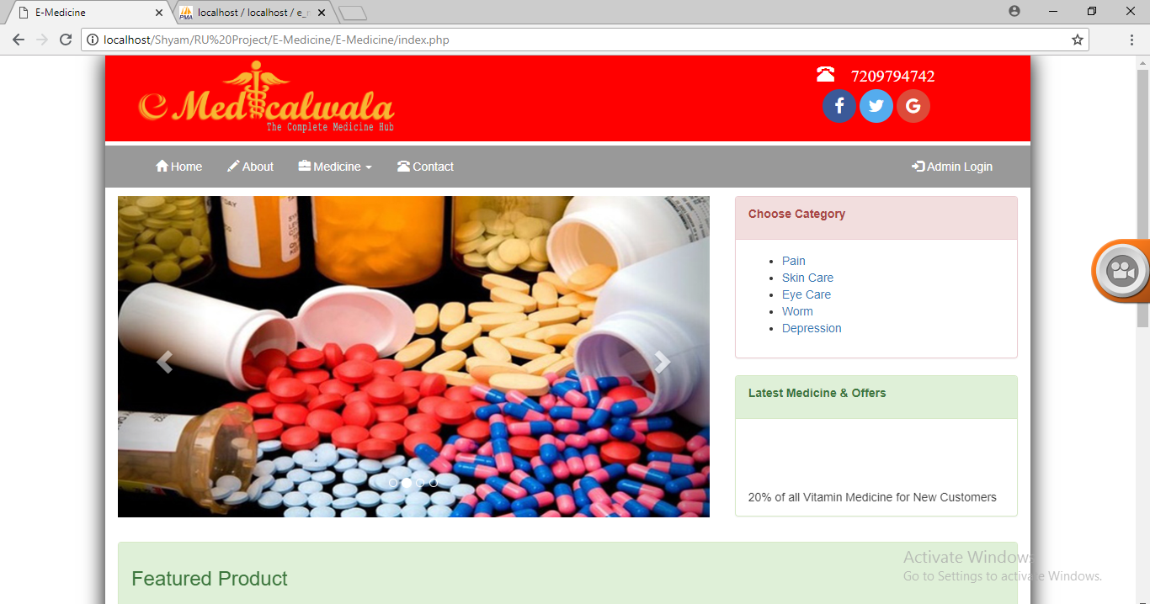

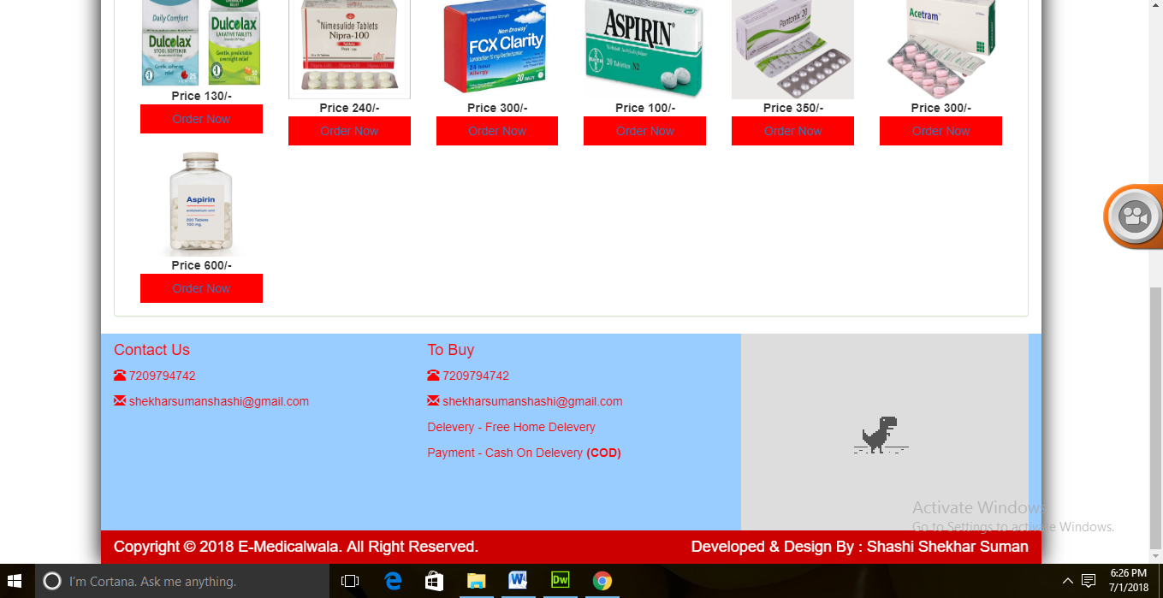

**About Page**

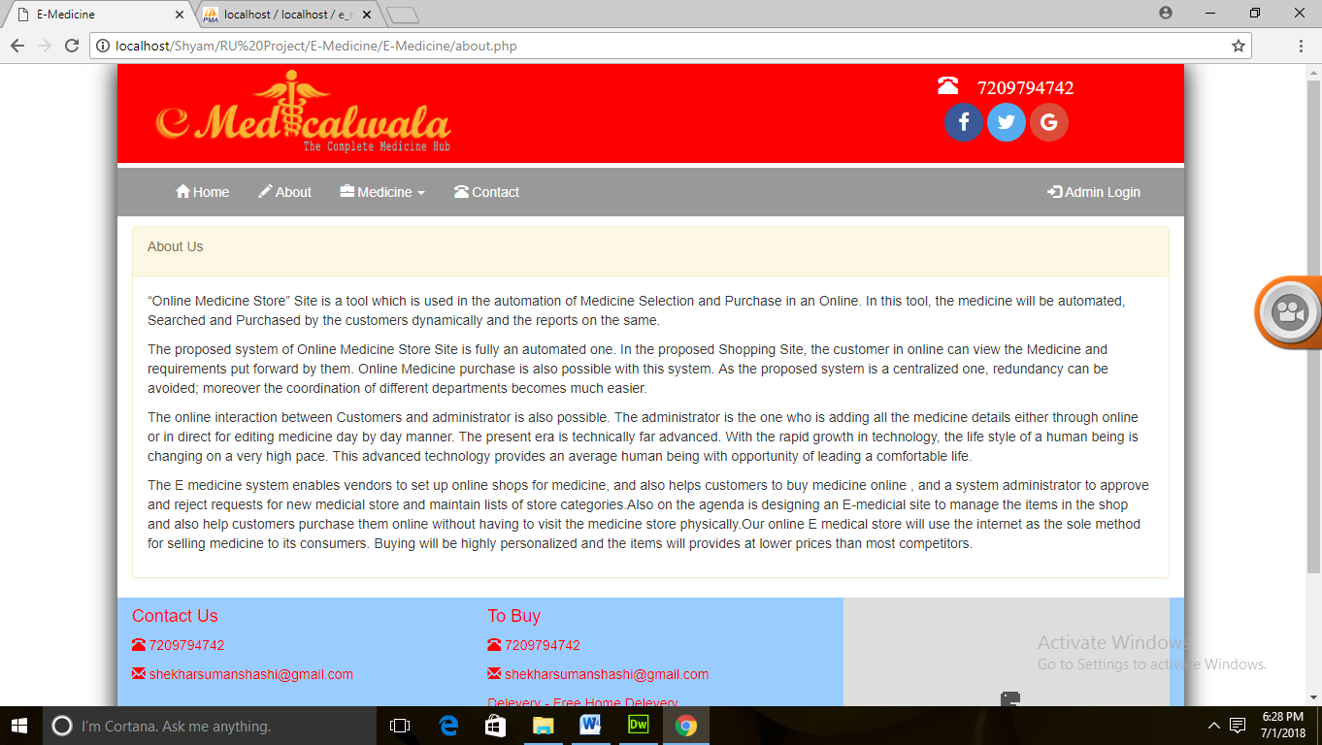

**Contact page**

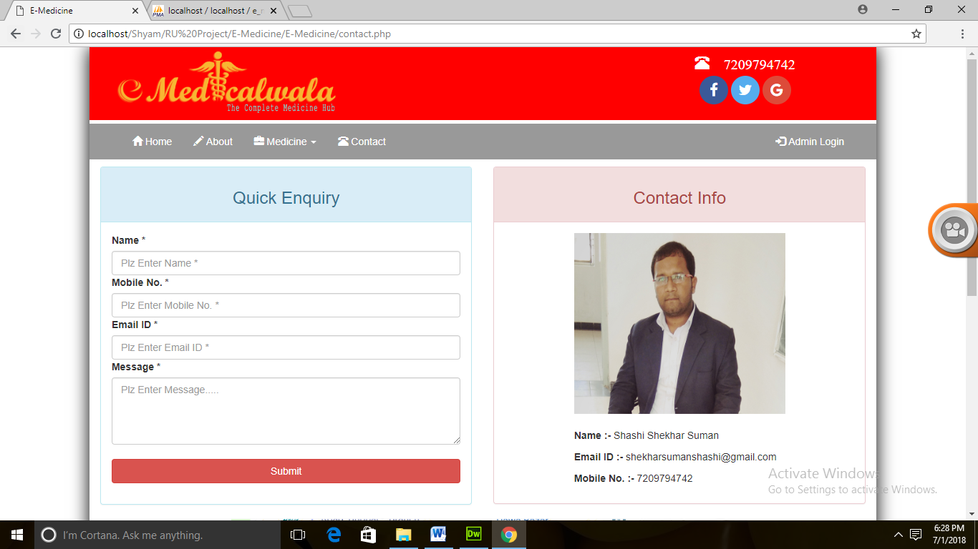

**Medicine pages**

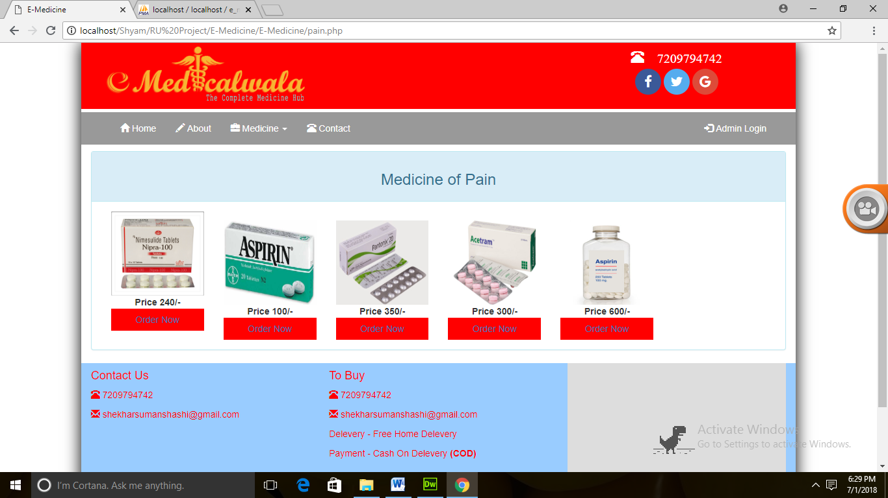

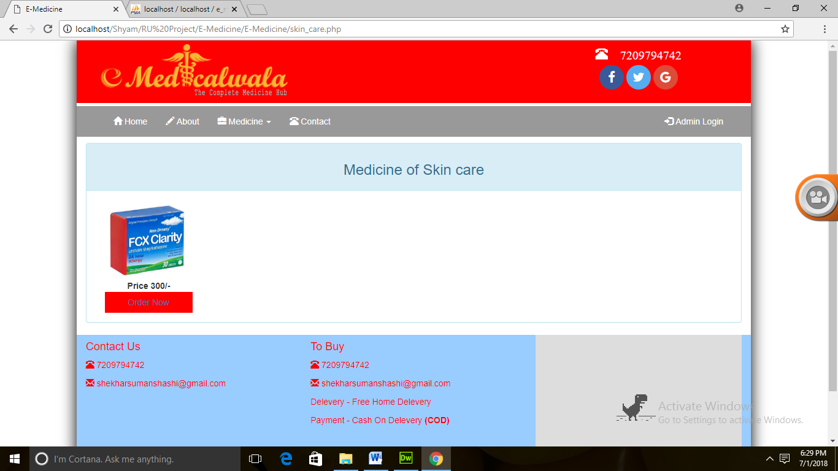

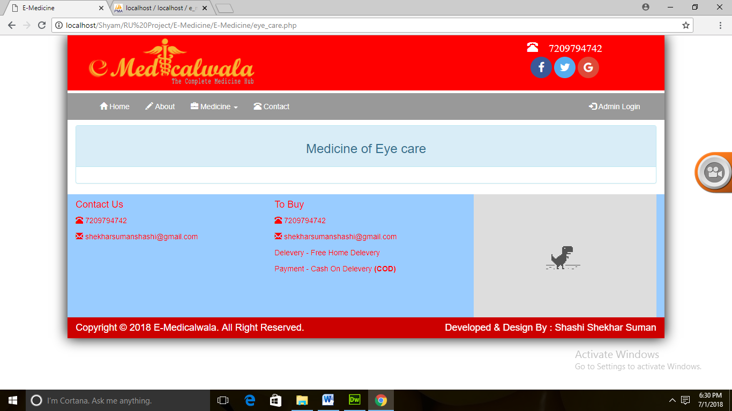

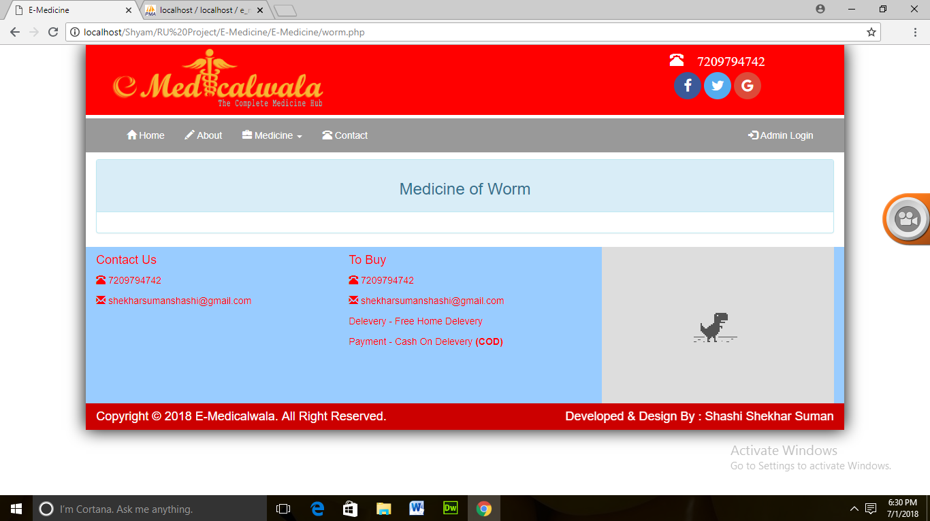

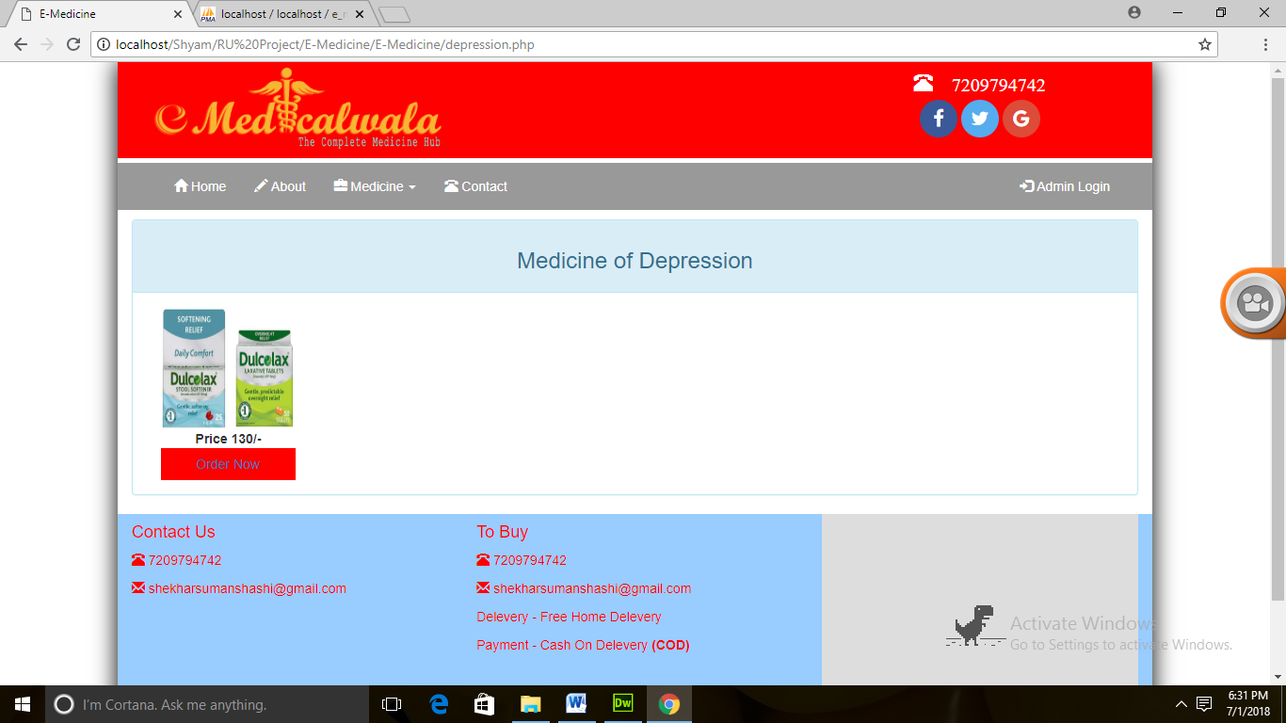

**Order Now Page**

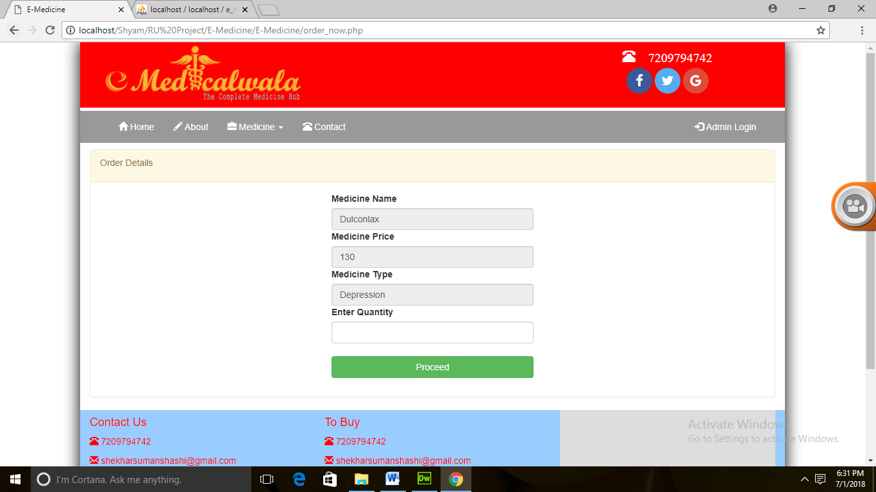

**Order Now Action Page**

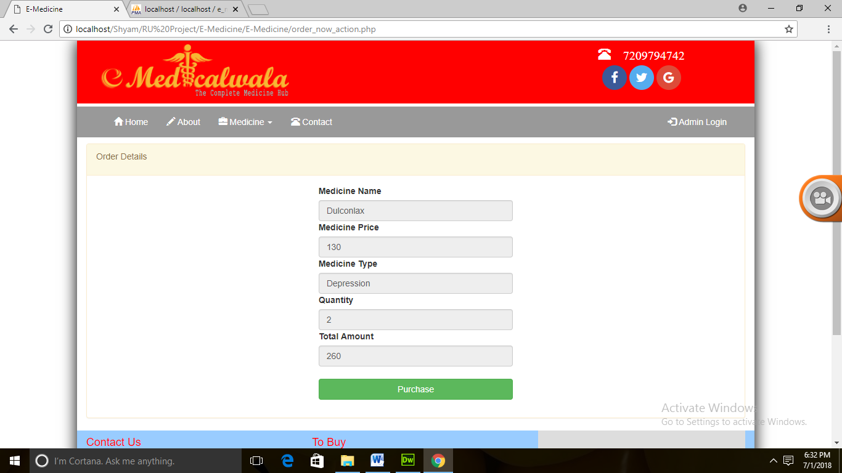

**Customer Login Page**

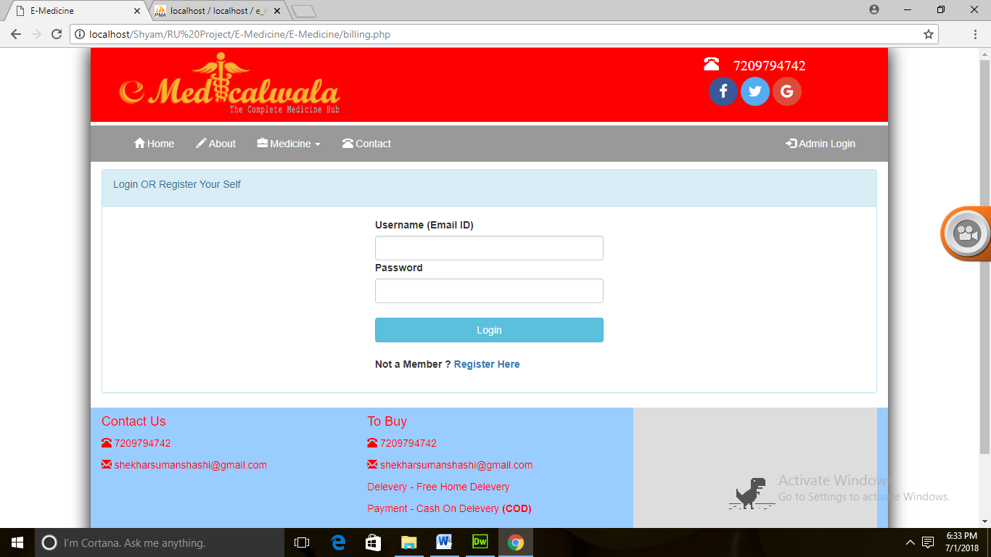

**Customer Register Page**

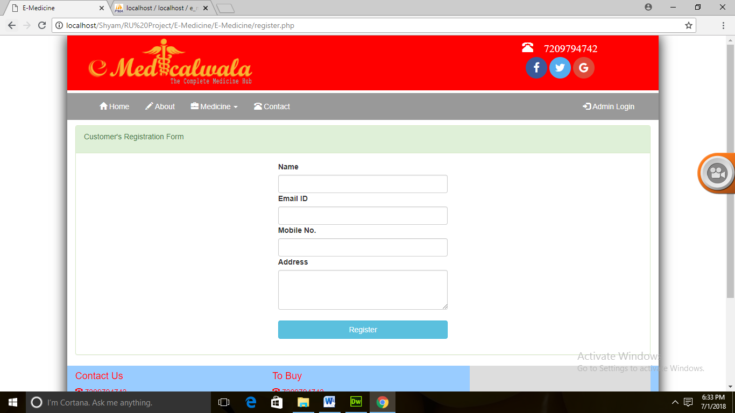

**Register Action Page**

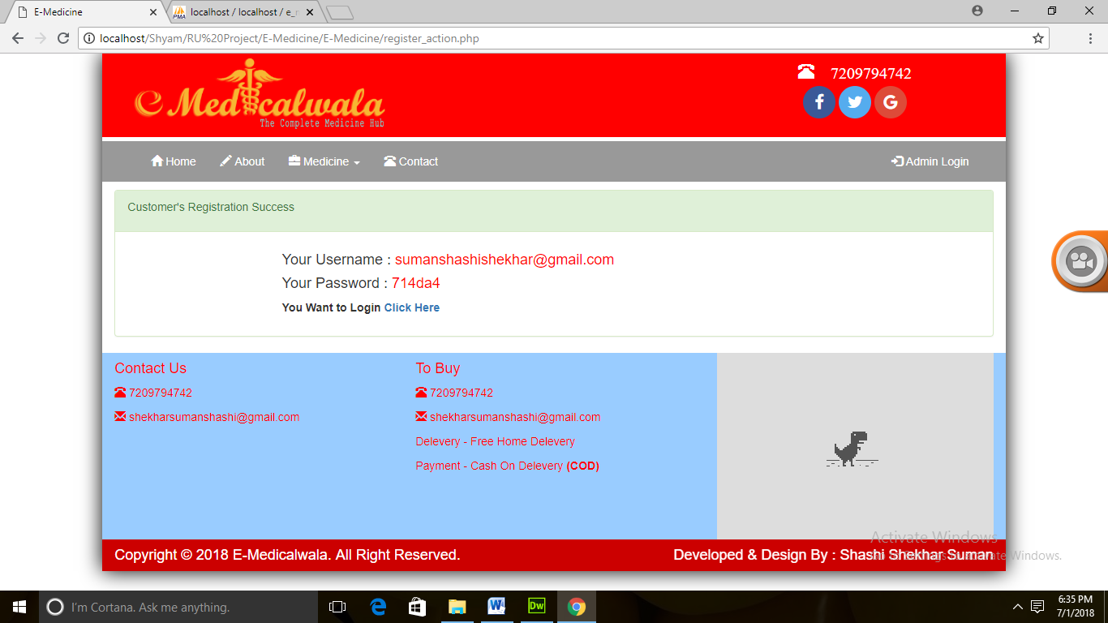

**After Customer Login Page**

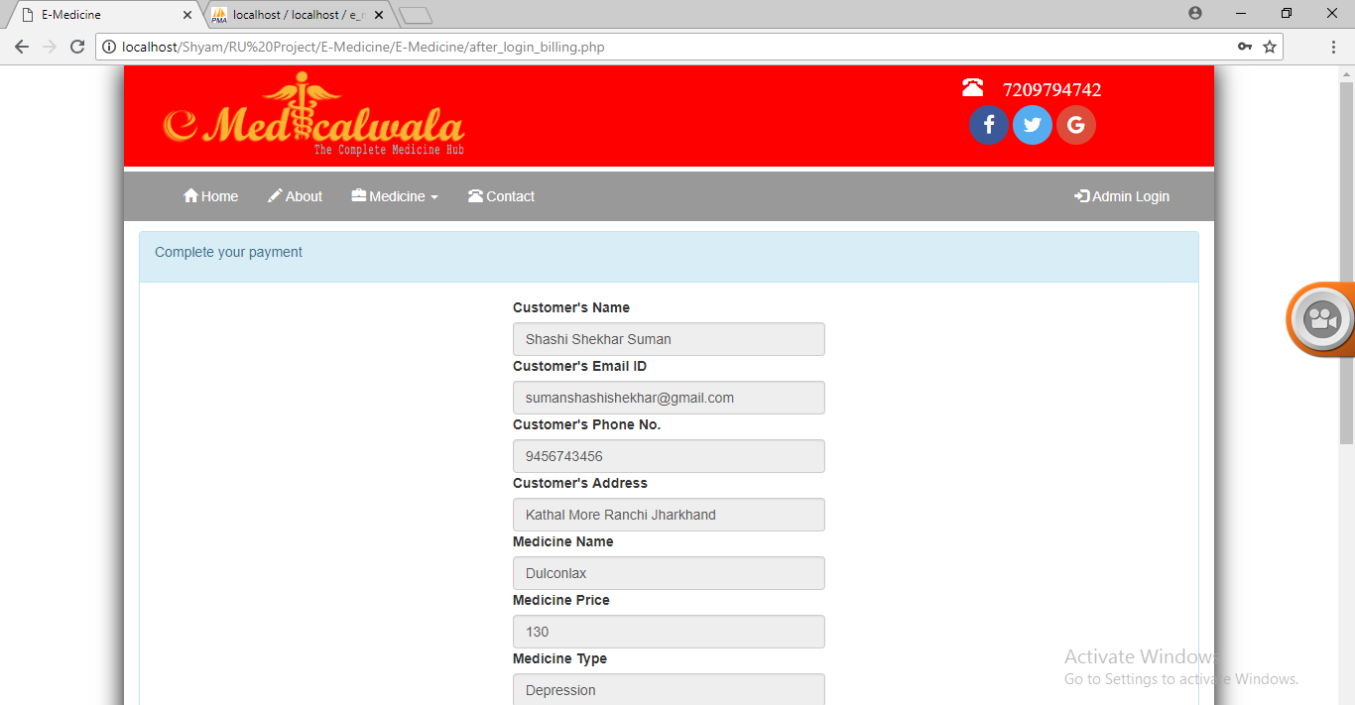

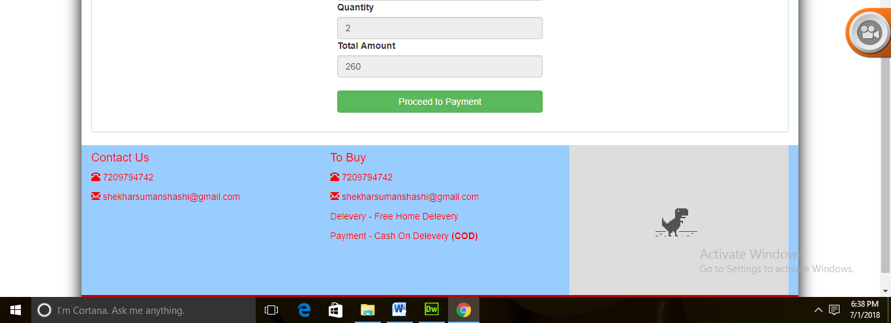

**Payment Page**

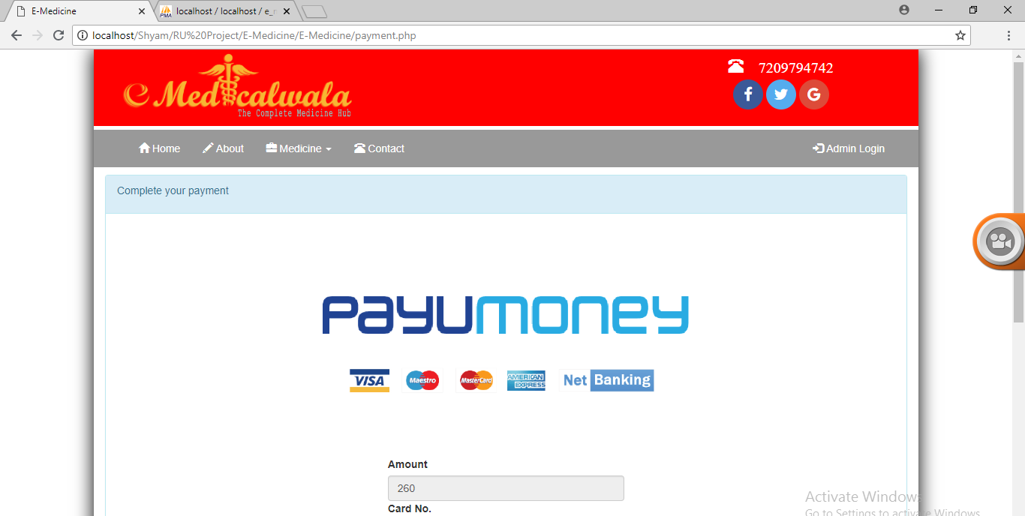

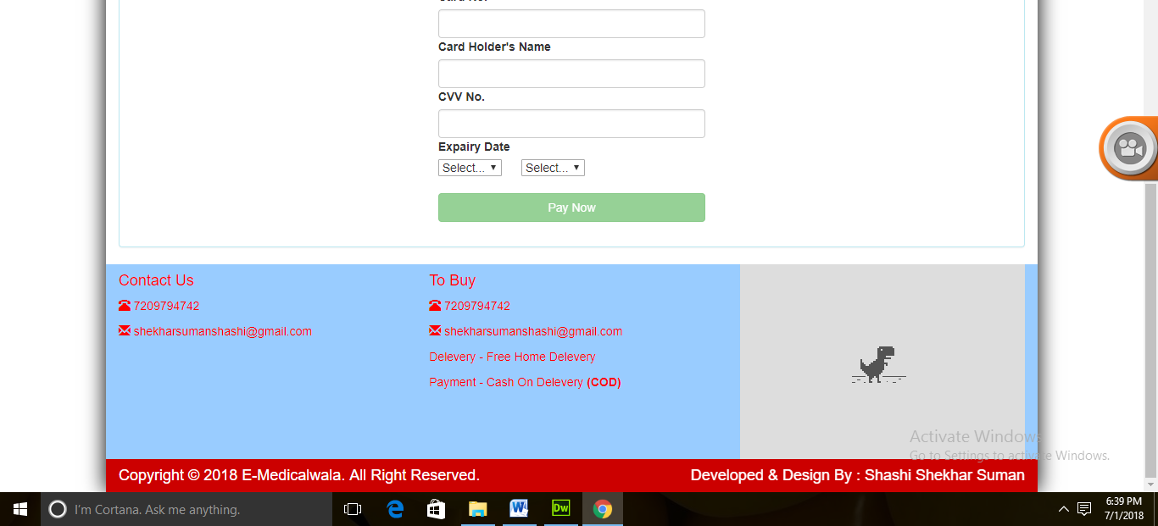

**Admin Login Page**

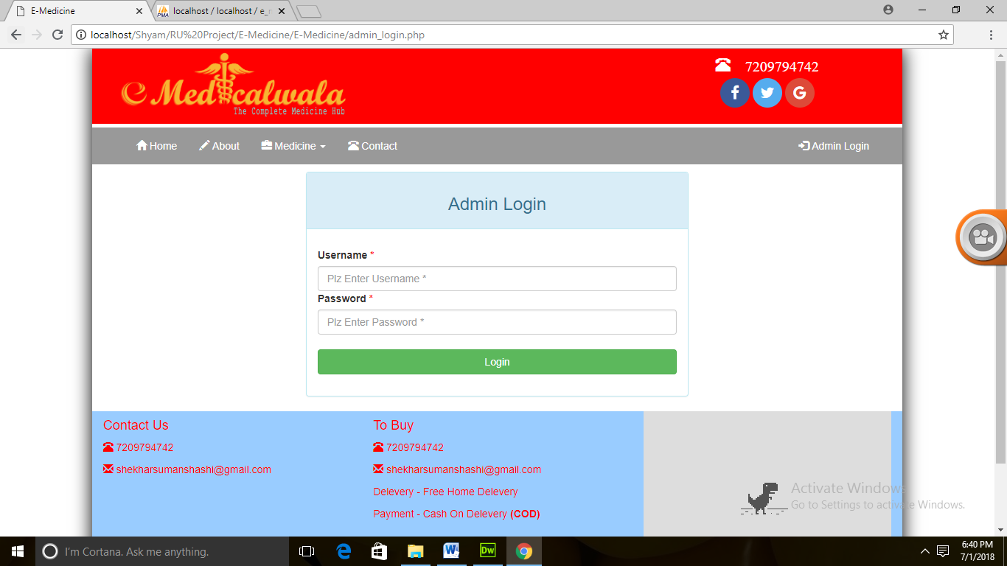

**Admin Panel**

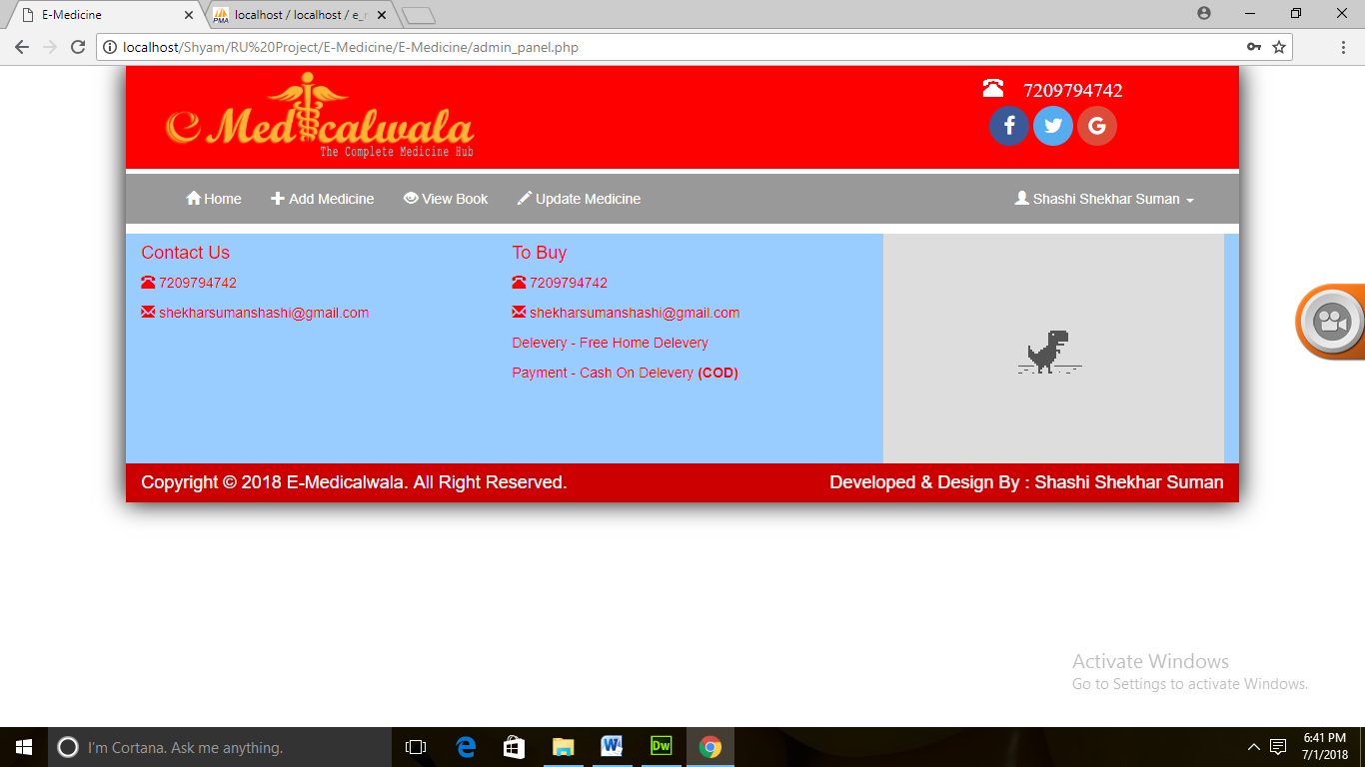

**Add Medicine Page**

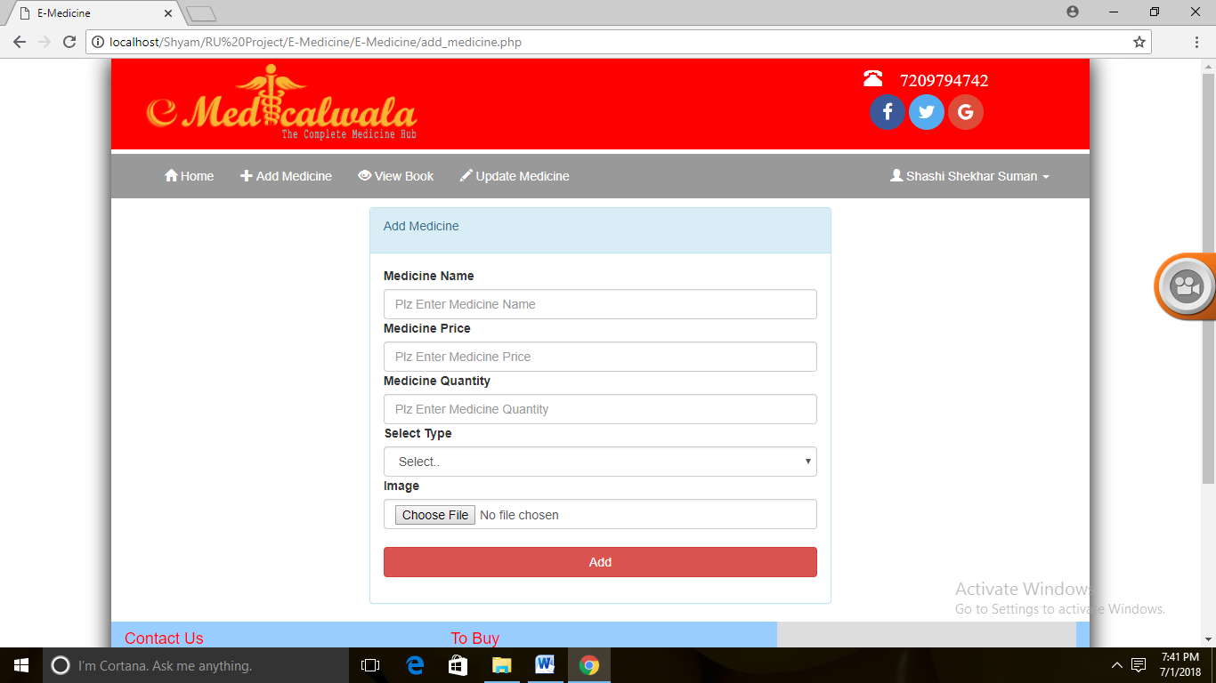

**View order Page**

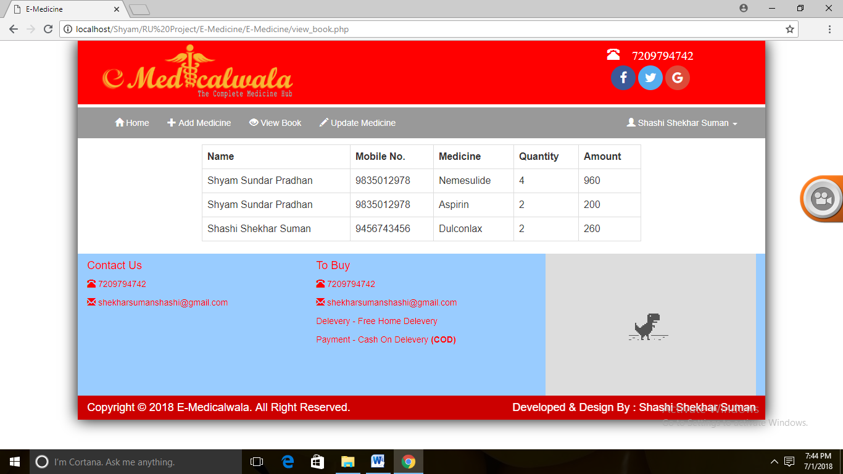

**Update Medicine Page**

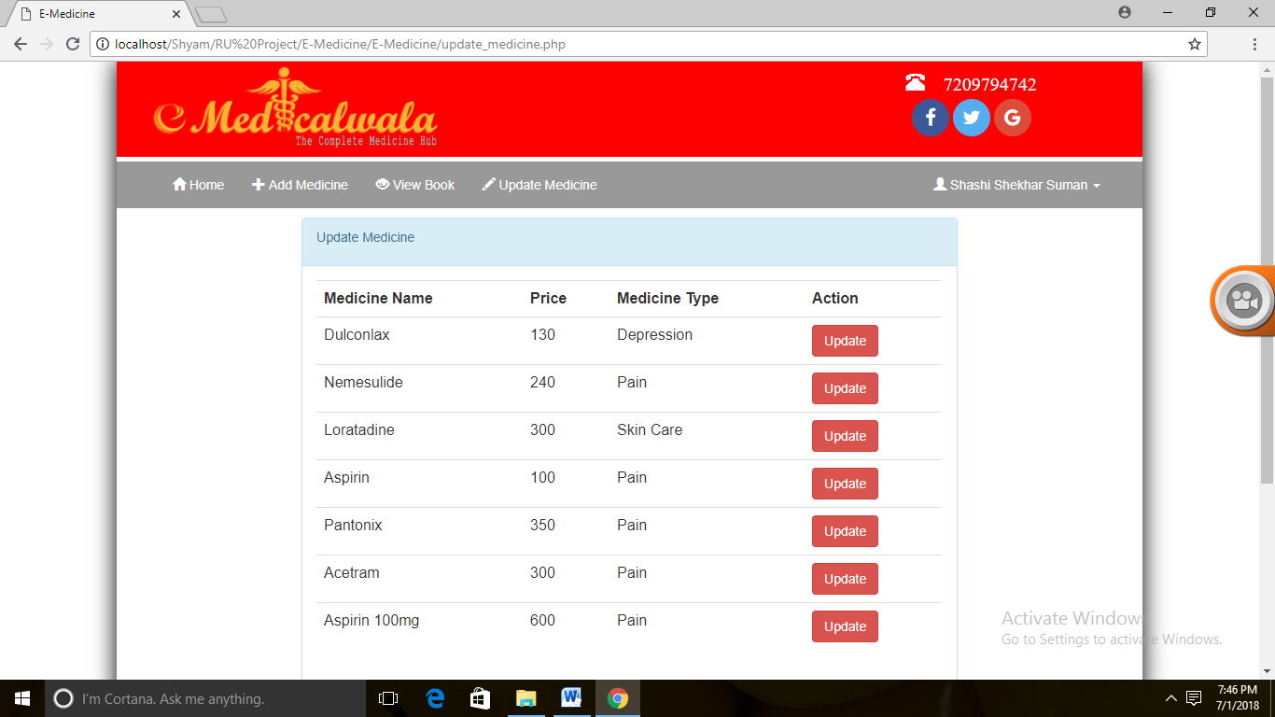**Update Medicine Action Page**

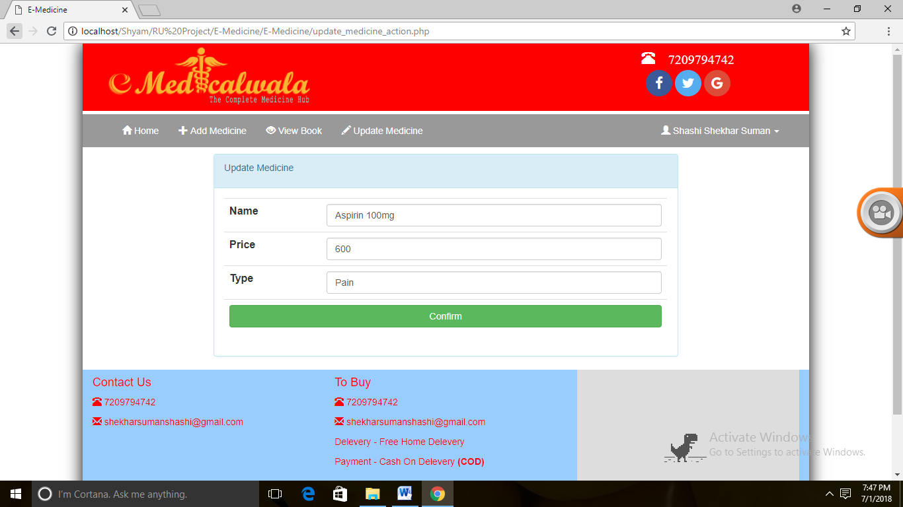

**FUTURE SCOPE**

###### FUTURE SCOPE

It has been a great experience implementing this project. This project title as “**E- MEDICINE** ” will be a great aid to general public and shopping administration. This project will reduce the work load of and will increase the efficiency.

This website will provide facilities such as cash on delivery, enables user to access there product details, management of medicine records by the shopping administration. Admin has the rights

To see that how many customers are buying products every day and also check the total daily transactions.

Some other features that helps it in gaining people interest are as follows:-

* + The entry of this project will bring a boom in market as it is based on completely new concept .
  + Interactive user interface will make it usage interesting.

This project will be a revolution in the private sector. The working of the e- medicine will be enhanced and better results will be obtained. The main thing is that it will provide satisfaction to the customer as now he can access his/her entire bill details and pay bill at one place. There is no chance of any kind of cheat. Thus this project has a great future.

Some other beneficiary features are:-

1. This project will reduce the paper work and hence nature friendly.
2. Interactive user interface will make its usage interesting.
3. Will reduce the manual load, hence less employees will be required in the accounts section.
4. Accurate calculations and results.
5. Time efficient.
6. The E medicine system enables vendors to set up online shops for medicine, and also helps customers to buy medicine online , and a system administrator to approve and reject requests for new medicial store and maintain lists of store categories

###### Further Enhancement of the Project:-

Everything that is made has some or the other things to be added to make it better than revolutions.

The project “E-medicine”, it has been tried to develop a robust and fault free system, still enough flexibility has been provided for further enhancements and modifications. As I mentioned earlier then the designed forms are typically reflections of the developer, so I strongly believe that the enhancement to be done with the project to be done with the design changes, coding changes. But at the same time I would like to mention that since one cannot claim himself as a master of the technology there is always some scope of technical modifications in the project that may lead to find code redundancy & storage space minimization.

Since the data is retrieved from the tables where everything is based on the coding system if the coding system is changed then the system needs to be redesigned.

**CONCLUSION**

###### Problems with conventional system

* + **Lack of immediate retrievals: -**The information is very difficult to retrieve and to find particular information like- E.g. - To find out about the order’s history, the user has to go through various registers. This results in inconvenience and wastage of time.
  + **Lack of immediate information storage: -** The information generated by various transactions takes time and efforts to be stored at right place.
  + **Lack of efficient billing: -** User have to add bill each time.
  + **Preparation of accurate and prompt : -** This becomes a difficult task as information is difficult to collect from various registers.

Hence, there is a need of reformation of the system with more advantages and flexibility. The Online medicine shopping System eliminates most of the limitations of the existing software. It has the following objectives:

###### Enhancement:

The main objective of Online Hospital Management System is to enhance and upgrade the existing system by increasing its efficiency and effectiveness. The software improves the working methods by replacing the existing manual system with the computer-based system.

###### Automation:

The Online medicine buying System automates each and every activity of the manual system and increases its throughput. Thus the response time of the system is very less and it works very fast.

###### Accuracy:

The Online medicine buying System provides the uses a quick response with very accurate information regarding the users etc. Any details or system in an accurate manner, as and when required.

###### User-Friendly:

The software Online medicine buying has a very user-friendly interface. Thus the users will feel very easy to work on it. The software provides accuracy along with a pleasant interface.Make the present manual system more interactive, speedy and user friendly.

REFERENCES

**References**

##### [www.w3school.com](http://www.w3school.com/)

* + [www.stackoverflow.com](http://www.stackoverflow.com/)
  + [www.tutorialpoints.com](http://www.tutorialpoints.com/)
  + [www.google.co.in](http://www.google.co.in/)
  + [www.wikipedia.com](http://www.wikipedia.com/)
  + HTML5 for Web Designers- **Jeremy Keith**
  + Pro CSS and HTML Design Patterns- **Sergey Mavrody**
  + JavaScript: A Beginner’s Guide, Third Edition- **John Pollock**

#### Beginning PHP5, 2004 edition- dave W. Mercer, Allan Kent etc